Meeting Minutes

Metropolitan Utility Coordinating Council
MUCC, PO Box 12001, Portland, OR 97212-0001

January 27, 2010
Our next meeting will be February 24, 2010 at the Village Inn in NE Portland

ATTENDEES: See attached listing.
_____________________________________________________________________

REPORTS:

Treasurer’s Report for June 2008: Only one transaction this month – payment for the booth for the 2010 Yard, Garden and Patio show.

M Bank Golf Fund Golf Fund Rodeo Visa
(Checking) (Savings)
Beginning Balance $ 4,171.77 $ 1,121.81 $ 5.00 $ 0.00 $ -
Ending Balance $ 3,476.77 $ 1,121.81 $ 5.00 $ 0.00 $ -

Payments / Purchases:
As a non-profit organization, all monies collected go for supplies/events to educate the public!
Our ending balance (total of all accounts) must be under $5,000 at the end of the year or we will have to pay (very high) taxes. There are opportunities coming up where we can get some good exposure to the public. See the P & E report.

Damage Report: See the end of the minutes.

P&E Report (Publicity and Education):

P&E General:

Don has an idea for a game to be played at the Yard Garden and Patio show – it will be similar to “Who wants to be a Millionaire?” The public will answer questions to win prizes.
Don Patterson has checked into the Chico Bag – a reusable bag in a pouch – as a handout. It can be printed with our logo and a minimum order costs $1,700/ 500 bags. We should consider going in with other UCC’s on an order like this. This bag is manufactured out of Chico California. Another suggestion was magnetized letter openers with the one-call number on them.

We are looking at different products for the smaller public events (those that last only a few hours).
Don suggested that we could participate in small community parades with our banner.

Clackamas Community College is open to presenting information about one-call at their landscaping classes and would like handouts. Other Community Colleges in the area should be contacted about also including the info in their classes.

Please send any ideas to help get the word out to Don Patterson (dwp@nwnatural.com) or to Anita Floyd (anita.floyd@qwest.com).

811 CAMPAIGN:
Home Depot is laying off people. The 811 campaign for Home Depot is on hold. Jarrod Morrison will find out if it will be revived.
The magnets are being updated to look more like the color code cards. Both are available.
You may go to www.call811.com website for more information.
______________________________________________________________________________________

REGIONAL LAW UPDATE: Has been cancelled until spring of 2010 and will be held in Coos Bay, May 13. It is free, includes lunch, and will have lots of SWAG. The local councils will be asked to recommend contractors for the Golden Shovel Award for exceptional prevention of damages. Send your recommendations to Gary Hyatt (gfh@nwnatural.com). They will be relying heavily on the councils to volunteer. Sign up will be at www.digsafelyoregon.com closer to the time of the events.
_________________________________________________________________________________________________________________________

Upcoming Events:

THE 2010 YARD, GARDEN AND PATIO SHOW:

Next show: Friday through Sunday – February 12-14, 2010 at the Convention Center
We need one more volunteer for the Saturday 10-2 shift – please call Don Patterson at (503) 226-4211 ext. 4387 if you are able to help at the show.

The OUNC has new thick standing pads to help prevent leg/foot fatigue while at the booth. They are very cushy and have the 811 logo on them.

Don Patterson showed us a photo of the new banner for the booth. The Council voted to buy four $50 gift certificates, one to give away each day of the show.

Don encouraged us to bring cameras if we are working the show, to get photos of the booth for use on the web site.

Gary Hyatt brought up the issue that it is hard to get volunteers for the show, and the same people volunteer every year. He suggested that we should consider not doing the show in the future, as there is a considerable cost for the booth and all the giveaways.

There will not be a Locate Rodeo this year. The OUNC agreed to make it a biennial event.
______________________________________________________________________________________________

OLD BUSINESS:

Very few complaints have been filed recently. PGE is going to start, as they have had some damages recently. Gary encouraged everyone to file complaints, as they are the best way to get the contractor’s attention.

NEW BUSINESS:

The issue of the meeting location was discussed. There was a consensus that the current location is centrally located, and it would be better to stay in the same place consistently. Many members were in favor of adding quarterly lunches in outlying areas, for people who cannot make it to the breakfast time or location.

APS contracted through DEA to work with BPA on their I-5 Reinforcement Program from Troutdale to Castle Rock. They are looking at utilities within 300’ of their facility. DEA is doing several projects for BPA. BPA is looking at different routes. They will probably start construction in the next year.

There is no locator certification. OUNC is working on some training.

Several members have had problems with not being able to get through to the phone number/person who called in the locate ticket. Gary suggested getting on the Construction Contractor Board or Landscaper Contractor Board web sites to get phone numbers.
______________________________________________________________________________________

Remember – CCC – Communicate, Coordinate, Cooperate!

VOLUNTEERS: As you have read, there are a variety of opportunities for all to volunteer and help spread the word of our Call before You Dig message. These are great opportunities to network and get to know each other better too. Take advantage of these opportunities and make new friends. If you are able, make yourself available to be on a committee or to volunteer on any of the upcoming projects and events these next couple of years. This is what this Council is all about and how we strive to be excellent!
______________________________________________________________________________________

OUNC OUCC
Oregon Utility Notification Center Oregon Utility Coordinating Council
www.digsafelyoregon.com www.oucc.net

Check out the websites for info on the Oregon Dig Law, upcoming events and on your local Council(s).
There are new changes to the website – check them out.
Also available: information on best practices at www.commongroundalliance.com
______________________________________________________________________________________

Respectfully submitted by Jane Estes.
______________________________________________________________________________________

The next meeting: Location: Village Inn at 1621 N.E 10th Ave in Portland
Date: Wednesday, February 24 at 7:30am

The 2010 schedule is the 4th Wednesday of each month except November

(the week before Thanksgiving) and December (no meeting).

January 27th February 24th March 24th April 28th
May 26th June 23rd July 28th August 25th

September 22nd October 27th November 17th Dec - No meeting

2009 MUCC PAID MEMBERS

As of 07-15-09

Applied Professional  Bones Construction, Inc.  City of Fairview  City of Gladstone  City of Gresham, OPS Center  City of Happy Valley  City of Hillsboro  City of Lake Oswego  City of Milwaukie  City of Oregon City  City of Tualatin  Civil Works NW Inc  Clackamas County | Comcast  Dirt & Aggregate Interchange, Inc.  Ditch Witch Northwest  Emery & Sons  Excel Excavation Inc  Henkels & McCoy  Knife River  Linescape  Locating Inc.  Loy Clark Pipeline  Multnomah County  North Sky Communications  Northwest Earthmovers, Inc. | ODOT  Oldcastle Precast  PacifiCorp / Pacific Power  Port of Portland  Portland General Electric  Qwest Communications  Robinson Bros Const Inc  Sunrise Water Authority  Tri-State Construction  Tualatin Valley Water District  Verizon  Washington County LUT  Williams Pipeline

2010 MUCC Executive Board
MUCC, PO Box 12001, Portland, OR 97212-0001

PRESIDENT:  Gary Hyatt  NW Natural  220 NW 2nd Ave, 3rd Floor  Portland OR 97209  Office - (503) 226-4211 ext 4320  gfh@nwnatural.com | VICE PRESIDENT / TREASURER:  Jarrod Morrison  Portland General Electric  3700 SE 17th Ave  Portland, OR 97202  Office - 503-736-5505  Cell - 503-849-7043  Fax - 503-736-5500  Jarrod.Morrison@pgn.com
SECRETARY:  Dawn Haase  Clackamas County DTD Eng  150 Beavercreek Rd  Oregon City OR 97045  Office – (503) 742-4682  Cell – (503) 789-5728  Fax – (503) 742-4659  dhaase@co.clackamas.or.us | PUBLICITY & EDUCATION:  Don Patterson  NW Natural  220 NW 2nd Ave, 3rd Floor  Portland OR 97209  Office - (503) 226-4211 ext 4387  Cell – 503-806-0845  Fax – (503) 273-4822  dwp@nwnatural.com

DAMAGE CHAIR:

Shannon Davis

Qwest

100 NW Kearney Ave
Bend, OR 97701

Office - 541-388-5296

Fax - 541 388-5269
Shannon.Davis@qwest.com

Damage Report
In 2010 we must have a minimum of three (3) damage reports per month. Submit your damages within 30 days.
From the Website http://oucc.net/ As of February 22, 2010:

November 2009: Eleven submittals for damages…

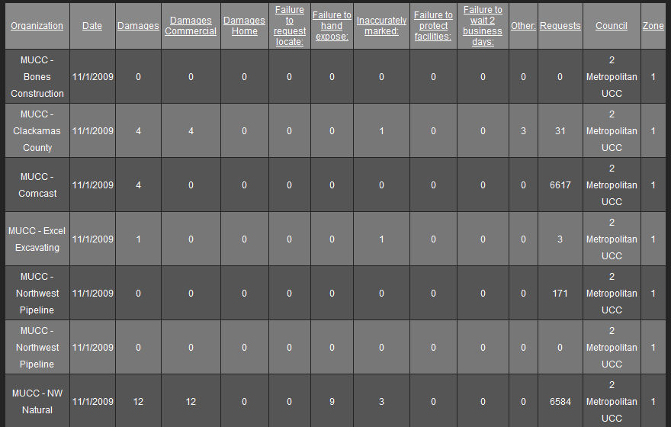

December 2009: Seven submittals for damages…
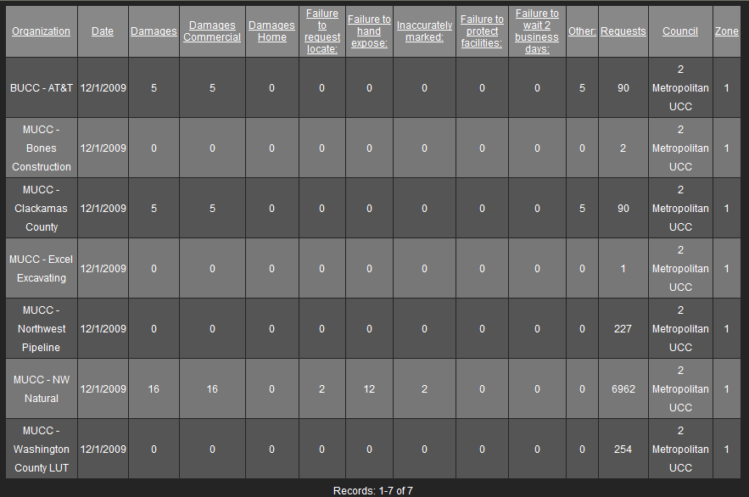

January 2010: Four submittals so far – Don’t forget to report your damages!

