Meeting Minutes

Metropolitan Utility Coordinating Council
MUCC, C/O Jarrod Morrison, 3700 SE 17th Ave, Portland, OR 97202

March 24, 2010
Our next meeting will be April 28, 2010 at the Village Inn in NE Portland

ATTENDEES: See attached listing.
__________________________________________________________________________________________________

REPORTS:

Treasurer’s Report for February 2010:

M Bank Golf Fund Golf Fund Rodeo Visa
(Checking) (Savings)
Beginning Balance $ 2,457.77 $ 1,121.81 $ 5.00 $ 0.00 $ -
Ending Balance $ 4,857.77 $ 1,121.81 $ 5.00 $ 0.00 $ -

Payments / Purchases / Income:
We received $1,000 from OUCC after we turned in the information they require each year. We have also received dues from eighteen various organizations. Please see the updated list near the end of the minutes – if your company is not listed, please send your dues to Jarrod Morrison at the address above.
As a non-profit organization, all monies collected go for supplies/events to educate the public!
Our ending balance (total of all accounts) must be under $5,000 at the end of the year or we will have to pay (very high) taxes.
There are opportunities coming up where we can get some good exposure to the public. See the P & E report.

Damage Report: See the end of the minutes.
The Common Ground Alliance (CGA) encourages the use of their Damage Information Reporting Tool (DIRT). Please check this out at www.cga-dirt.com

P&E Report (Publicity and Education):

P&E General:
New:
April is National Safe Digging Month! There will be new radio and TV ads coming out.
It has been found that some of the 811 locators are telling the home owners who call in for locates that they need private locates and not to call 811. We need to get better information for the home owners who need locates on their private lines, by adding something in the general message when they call 811 and with a link to a website to the contractors who do private locating.

Old:
The Yard, Garden & Patio show went very well – there were lots of questions asked by the public, and stories were shared. We would like to thank all of the volunteers who helped to make the YGP a huge success – Thank You!! If you were not reimbursed for your parking pass – contact Jarrod Morrison.
At the P&E meeting for the OUNC they are looking for new promotional items. Send your ideas to Don Patterson (dwp@nwnatural.com).
Don Patterson has checked into the Chico Bag – a reusable bag in a pouch – as a handout. It can be printed with our logo and a minimum order costs $1,700/ 500 bags. We should consider going in with other UCC’s on an order like this. This bag is manufactured out of Chico California. Another suggestion was magnetized letter openers with the one-call number on them.
We are looking at different products for the smaller public events (those that last only a few hours).
Don suggested that we could participate in small community parades with our banner.
Clackamas Community College is open to presenting information about one-call at their landscaping classes and would like handouts. Other Community Colleges in the area should be contacted about also including the info in their classes.
Please send any ideas to help get the word out to Don Patterson (dwp@nwnatural.com) or to Anita Floyd (anita.floyd@qwest.com).

811 CAMPAIGN:
Home Depot is laying off people. The 811 campaign for Home Depot is on hold. Jarrod Morrison will find out if it will be revived.
The magnets are being updated to look more like the color code cards. Both are available.
You may go to www.call811.com website for more information.
______________________________________________________________________________________

REGIONAL LAW UPDATE: Will be held in Coos Bay, May 13, 2010. It is free, includes lunch, and will have lots of SWAG. The local councils will be asked to recommend contractors for the Golden Shovel Award for exceptional prevention of damages. Send your recommendations to Gary Hyatt (gfh@nwnatural.com). They will be relying heavily on the councils to volunteer. Sign up will be at www.digsafelyoregon.com closer to the time of the events.
____________________________________________________________________________________________________________

Upcoming Events:

2010 GOLF TOURNAMENT:
The date is set for July 23rd, 2010 with a 7:30 shotgun start. Start thinking about joining the fun – either by playing or by volunteering at the event! The Committee will be meeting after the next MUCC meeting.

2011 LOCATE RODEO:
There will not be a Locate Rodeo in 2010. The OUNC agreed to make it a biennial event.
_______________________________________________________________________________________

OLD BUSINESS:

RAA - The next RAA hearing is on March 30th, 2010 at the PUC Building at 550 Capitol St NE, Salem. They will have two hearings – the first at 9:00 and the second at 10:00.
Very few complaints have been filed recently. PGE is going to start, as they have had some damages recently. Gary encouraged everyone to file complaints, as they are the best way to get the contractor’s attention.
Several members have had problems with not being able to get through to the phone number/person who called in the locate ticket. Gary suggested getting on the Construction Contractor Board or Landscaper Contractor Board web sites to get phone numbers.

NEW BUSINESS: (None at this time.)
______________________________________________________________________________________

Remember – CCC – Communicate, Coordinate, Cooperate!
______________________________________________________________________________________________________________________________________________

VOLUNTEERS: As you have read, there are a variety of opportunities for all to volunteer and help spread the word of our Call before You Dig message. These are great opportunities to network and get to know each other better too. Take advantage of these opportunities and make new friends. If you are able, make yourself available to be on a committee or to volunteer on any of the upcoming projects and events these next couple of years. This is what this Council is all about and how we strive to be excellent!
_______________________________________________________________________________________

Oregon Utility Notification Center Oregon Utility Coordinating Council
www.digsafelyoregon.com www.oucc.net

Check out the websites for info on the Oregon Dig Law, upcoming events and on your local Council(s).
There are new changes to the website – check them out.
Also available: see information on best practices at www.commongroundalliance.com
_______________________________________________________________________________________

Respectfully submitted by Dawn Haase.
_______________________________________________________________________________________
The next meeting: Date: Wednesday, April 28th at 7:30am
Location: Village Inn at 1621 N.E 10th Ave in Portland

The 2010 schedule is the 4th Wednesday of each month except November

(the week before Thanksgiving) and December (no meeting).

January 27th February 24th March 24th April 28th
May 26th June 23rd July 28th August 25th

September 22nd October 27th November 17th Dec - No meeting
______________________________________________________________________________________

2010 MUCC Executive Board
MUCC, C/O Jarrod Morrison, 3700 SE 17th Ave, Portland, OR 97202

PRESIDENT: Gary Hyatt, NW Natural, 220 NW 2nd Ave, 3rd Floor, Portland OR 97209

Office - (503) 226-4211 ext 4320, gfh@nwnatural.com

VICE PRESIDENT / TREASURER: Jarrod Morrison, Portland General Electric , 3700 SE

17th Ave, Portland, OR 97202, Office - 503-736-5505, Cell - 503-849-7043
Fax - 503-736-5500, Jarrod.Morrison@pgn.com

SECRETARY: Dawn Haase, Clackamas County DTD Eng, 150 Beavercreek Rd
Oregon City OR 97045, Office – (503) 742-4682, Cell – (503) 789-5728
Fax – (503) 742-4659, dhaase@co.clackamas.or.us

PUBLICITY & EDUCATION: Don Patterson, NW Natural, 220 NW 2nd Ave, 3rd Floor

Portland OR 97209, Office - (503) 226-4211 ext 4387, Cell – 503-806-0845
Fax – (503) 273-4822, dwp@nwnatural.com

DAMAGE CHAIR: Shannon Davis, Qwest, 100 NW Kearney Ave, Bend, OR 97701

Office - 541-388-5296, Fax - 541 388-5269, Shannon.Davis@qwest.com

2010 MUCC PAID MEMBERS

As of 04-26-10
Bones Construction, Inc.  City of Gresham, OPS Center  City of Hillsboro  City of Lake Oswego  City of Milwaukie  City of Oregon City  City of Sandy  City of Tigard  City of Tualatin  Clackamas County  Comcast | Dirt & Aggregate Interchange, Inc  Ditch Witch Northwest  Emery & Sons Construction  James W Fowler Co.  K&D Services of Oregon, Inc.  Lakeside Industries  Locates Down Under  Locating, Inc  Loy Clark Pipeline  Multnomah County | North Sky Communications  Oldcastle Precast  PacifiCorp / Pacific Power  Portland General Electric  Qwest  Sunrise Water Authority  Superior Fence Construction  Tri-State Construction  Tualatin Valley Water District  Washington County LUT  Williams Pipeline
______________________________________________________________________________________

Damage Report
In 2010 we must have a minimum of three (3) damage reports per month. Please submit your damages within 30 days. The following is from the Website http://oucc.net/ taken April 26, 2010:

January 2010: Six submittals for damages…
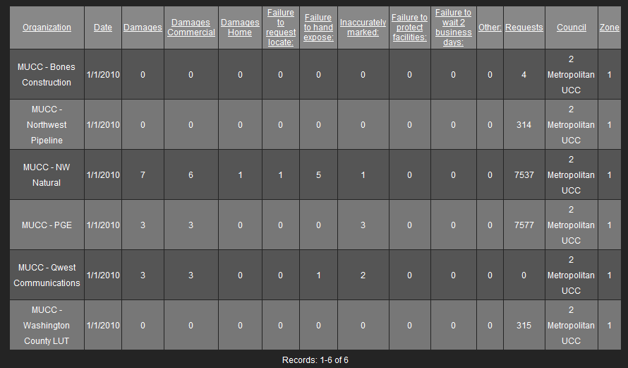

February 2010: Five submittals for damages…
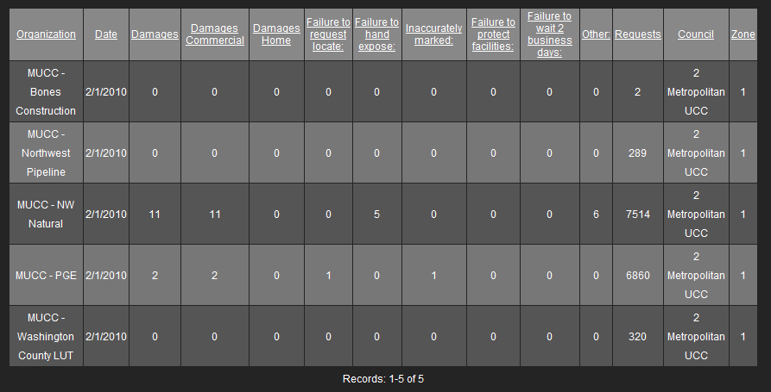

March 2010: Four submittals so far – Don’t forget to report your damages!

