Meeting Minutes

Metropolitan Utility Coordinating Council
MUCC, C/O Jarrod Morrison, 3700 SE 17th Ave, Portland, OR 97202

May 25th, 2011
Our next meeting will be June 22nd, 2011
At the Busters Texas Style BBQ, 11419 SW Pacific Hwy. Tigard, OR 97223
http://www.yellowpages.com/portland-or/mip/busters-texas-style-barbecue-6019587/map?lid=6019587
(Control +Click mouse on link for map directions)

ATTENDEES: See attached listing.
__________________________________________________________________________________________________

REPORTS:

Treasurer’s Report for April 2011: 2 checks written: $100 to Don Patterson for Earth Day gift cards &
$250 to Stone Creek Golf Course for tournament deposit
M Bank Golf Fund Golf Fund Rodeo Visa
(Checking) (Savings)
Beginning Balance $ 5,470.70 $ 1,121.81 $ 5.00 $ 0.00 $ -
Ending Balance $ 5,120.70 $ 1,121.81 $ 5.00 $ 0.00 $ -

Payments / Purchases / Income:
We have received dues from a total 35 members which have been posted. $2,050.00 were deposited this month.
As a non-profit organization, all monies collected go for supplies/events to educate the public!
Our ending balance (all accounts) must be under $5,000 at the end of the year or we will have to pay taxes.

Damage Report: See the end of the minutes.

We must now have five (5) entities reporting monthly – be sure to report your damages in a timely manner!
The Common Ground Alliance (CGA) encourages the use of their Damage Information Reporting Tool (DIRT). You can check this out at www.cga-dirt.com

P&E Report (Publicity and Education):

P&E General: Send your ideas to Don Patterson (dwp@nwnatural.com) and Anita Floyd (anita.floyd@qwest.com)

New: No New Information.

Old:
Don Patterson is working hard to find local media venues to get the word out. If you have any contacts at your local newspapers or radio stations, please pass on that contact info to him.
Radio update – There is an issue with the wording in the radio ads – the phrase “48 business hours” should be “2 business days”. “48 business hours” sounds like it could take 4-6 days for the locate. We are getting good coverage in the local area.
Summer Events – we are hoping to have a booth at some of the smaller local (one-day) events in the Tri-County area. Please let Don know what local Fairs and Festivals are in your area so he can check into setting up our booth at these events.
We are looking for local community sponsors! Please talk to any of our local vendors who sell/rent items where it would benefit us and the public to have our handout in the store. If the store will agree to have our handouts available for the public, pass their contact info on to Don to get it set up. If the store wants to make a donation for a giveaway at one of the events that we attend, that would be great as well, but it is not required. We mostly want to get our handouts into their stores so the public has access to it!
A couple events that are coming up that we can discuss attending are the Crawfest Festival in August, and the Mississippi Street Fair. More details to follow.
Newspaper Ad Update – Don has checked into some of the local newspapers to put our ad in several. One price he found was a one-time ad for 2 newspapers for $174. This was for the Tualatin and Tigard newspapers. We are hoping to hit newspapers in the Tri-County area at the best price we can find. We would like to do it for the months of April through July when spring planting and fencing is going strong. We will discuss this more at the April meeting, as NW Natural will be doing their own ad for the month of April. A motion to spend $500 toward newspaper ads was brought to the floor, and tabled until further discussion
See Upcoming Events / Meetings for the Locator Training Sessions this year.

There is a lot happening these next few months. They are planning to spend about $40,000 next year toward radio advertising.
Home Depot has embraced its partnership with the CGA in this region. The CGA may talk with Lowes and other large stores to promote 811.

April 2011 should be next year’s Dig Safe Month. Don will work on getting multiple UCC’s to get together and do some radio ads and maybe some printed ads for that month.

Columbia Gorge/Hood River areas are planning radio ads to promote 811 as well as using small newspaper ads. Don Patterson has checked into our local area and found that there is one radio company that owns about a dozen smaller newspapers in the local region. We can run a single ad (3.5” x 4” in color) in these local papers for just $145/month. Don Patterson will put together a proposal for our information and vote for the next MUCC meeting. We are thinking of doing several months of advertising this summer/fall and perhaps 6 months of advertising next year.
OUNC is looking for new promotional items.
Requests for cards/pens/hats/other items are being downsized because OUNC doesn’t want to run out of inventory. Please only order what you really need.

811 CAMPAIGN: (No new information this month)
Home Depot is breaking out in the western region. Go into your local Home Depot and if you do not see the 811 info, ask at the Contractors desk.
In Oregon, the stores will carry Key Chains for all equipment and color code cards. The “Associates” who will be trained to answer questions will have patches on their aprons.
The OUNC meets the 2nd Wednesday of the month at the One Call Center in Portland.
You may go to www.call811.com website for more information.
____________________________________________________________________________________________________________

Upcoming Events / Meetings:

MUCC’S 7TH ANNUAL GOLF SCRAMBLE: July 22nd 2011 Stone Creek Golf Course 21011 S Hwy 213, Oregon City, OR. Registration and fees are due by July 15th. (See attachment for registration form)

UTILITY LOCATOR TRAINING SESSION: July 28 – 29, 2011 8:30am – 4:00 Clackamas Community College –Wilsonville Campus –Room 111, 29353 SW Town Center Loop E, Wilsonville, OR 97070 (Registrations now being taken) go on line to: http://digsafelyoregon.com/locator-training-2011.asp

NW CGA MEETING: JUNE 30, 2011 Red Lion Templins, Post Falls Idaho. 10am to 4pm

UTILITY LOCATOR TRAINING SESSION: September 13 – 14, 2011 Central Point, OR (location TBD) – registration is not available at this time. Check back for updates on registration opening.

2011 LOCATE RODEO: There will not be a Locate Rodeo in 2011. This will be a biennial event. Time to start putting the Committee together!

REGIONAL LAW UPDATE: The Coos Bay event has been postponed (indefinitely). There was a roadblock trying to get the lists of people for attendees. Updates to follow as they come in.
_______________________________________________________________________________________

OLD BUSINESS:

RAA - The next hearing date unknown.
Hearings are at the PUC Building at 550 Capitol St NE, Salem. Be sure to bring change for the parking meters if you attend. The OUNC has asked Michael Thompson to put together a summary of the RAA hearings. This would benefit the local councils to help promote education to the local contractors in the areas where infractions are the highest.

If you know of any websites that could benefit by having a link to our website, please pass the website on to Don Patterson to check it out. Getting our link onto other websites is a good way to be visible online and can reach many people.
Gary Hyatt asked for prize Give Away’s, if your company has items to donate, please bring them in or let us know how you can help. Also Gary would like for volunteer guest speakers to come in with presentations to our meetings.

811 Locate Requesting is available 24/7/365! Don’t wait until first thing Monday morning to call in your locates – you’ll find the lines are packed with everyone else calling at the same time! Call Saturday or Sunday if you want to get your request in early. Still expect two (2) business days for the locates to show up!
Should you encounter an un-located utility while excavating – stop digging, call 811 to report it immediately, determine that there is no immediate danger, and you can continue working (if your project allows) using extreme care in the affected area. See Page 23 (5) in the Standards Manual.

NEW BUSINESS:
Our lunch was sponsered by Cardno TBE. Jesse Nemec with Cardno TBE gave a presentation on Subsurface Utility Engineering.

Jarrod Morrison notified us that the MUCC, had been asked to join in with Mid Willamette UCC & Yamhill UCC to sponsor a Fishing Derby On July 23rd, (see attachment) Our sponsorship due’s are $350. Jarrod motioned the sponsorship, motion was seconded & granted. He will write a check for the $350.

Jarrod talked about the use of contact information provided by OUNC, that is being used by a Private locate company (CNI) for the the sale of their service. Frank with OUNC will be adding a disclaimer of the use of this information provided by OUNC.

One Call #’s are still down!

We are still looking for a guest speakers!
If your company is able to give a presentation at one of the upcoming meetings, please let us know.

REMINDER…Send your current and/or upcoming projects to Marta Padilla @ marta.padilla@locatinginc.com and they will be attached to the Minutes e-mail so everyone will know where projects are or will be happening and your company can schedule accordingly.
______________________________________________________________________________________

Remember – CCC – Communicate, Coordinate, And Cooperate!
______________________________________________________________________________________________________________________________________________

VOLUNTEERS NEEDED: As you have read, there are a variety of opportunities for all to volunteer and help spread the word of our Call before You Dig message. These are great opportunities to network and get to know each other better. Take advantage of these opportunities and make new friends. If you are able, make yourself available to be on a committee or to volunteer on any of the upcoming projects and events these next couple of years. This is what this Council is all about and how we strive to be excellent!
_______________________________________________________________________________________
Oregon Utility Notification Center  www.digsafelyoregon.com | Oregon Utility Coordinating Council  www.oucc.net

Check out the websites for info on the Oregon Dig Law, upcoming events and on your local Council(s).
There are new changes to the website – check them out.
Also available: see information on Best Practices at www.commongroundalliance.com
_______________________________________________________________________________________

Respectfully submitted by Marta Padilla.
_______________________________________________________________________________________

The next meeting: Date: Wednesday June 22^{nd,},@ 11:30am
Location: Buster’s BBQ, 11419 SW Pacific Hwy Portland, OR http://www.yellowpages.com/portland-or/mip/busters-texas-style-barbecue-6019587/map?lid=6019587

The 2011 schedule is the 4th Wednesday of each month except November

(the week before Thanksgiving this year) and December (no meeting).

January 26th February 23rd March 23rd April 27th
May 25th June 22nd July 27th August 24th

September 28th October 26th November 16th Dec - No meeting
______________________________________________________________________________________

2011 MUCC Executive Board
MUCC, C/O Jarrod Morrison, 3700 SE 17th Ave, Portland, OR 97202

PRESIDENT: Gary Hyatt, NW Natural, 220 NW 2nd Ave, 3rd Floor, Portland OR 97209

Office - (503) 226-4211 ext 4320, gfh@nwnatural.com

VICE PRESIDENT / TREASURER: Jarrod Morrison, Portland General Electric, 3700 SE

17th Ave, Portland, OR 97202, Office – (503) 736-5505, Cell - (503) 849-7043
Fax - (503) 736-5500, Jarrod.Morrison@pgn.com

SECRETARY: Marta Padilla, Locating Inc, 6601 NE 78th Ct, Portland OR 97218
Office – (503) 255-4634, marta.padilla@locatinginc.com

PUBLICITY & EDUCATION: Don Patterson, NW Natural, 220 NW 2nd Ave, 3rd Floor

Portland OR 97209, Office - (503) 226-4211 ext 4387, Cell – (503) 806-0845
Fax – (503) 273-4822, dwp@nwnatural.com

DAMAGE CHAIR: Shannon Davis, Qwest, 100 NW Kearney Ave, Bend, OR 97701

Office – (541) 388-5296, Fax – (541) 388-5269, Shannon.Davis@qwest.com

2011 MUCC PAID MEMBERS

As of 04-14-11
Advantage Drilling LLC  Bones Construction, Inc.  BP Olympic Pipeline  City of Gladstone  City of Gresham, OPS Center  City of Hillsboro  City of Lake Oswego  City of Oregon City  City of Sandy  City of Tualatin  Clackamas County  Clackamas River Water | Comcast  Dirt & Aggregate Interchange, Inc  Ditch Witch Northwest  Gonzales Boring & Tunneling, Inc  Henkels & McCoy  James W Fowler Co.  Knife River  Linescape  Locating, Inc  Loy Clark Pipeline  Multnomah County  North Sky Communications | Northwest Pipeline  NW Natural  ODOT  Old Castle Precast  Pacificorp/Pacific Power  Port of Portland  Portland General Electric  Qwest Communications  Sunrise Water Authority  Superior Fence Construction  Washington County LUT

Damage Report: In 2011 we must have a minimum of five (5) damage reports per month. Please submit your damages within 30 days. The following is from the Website http://oucc.net/ taken June 17, 2011.
February 2011: Four submittals for damages…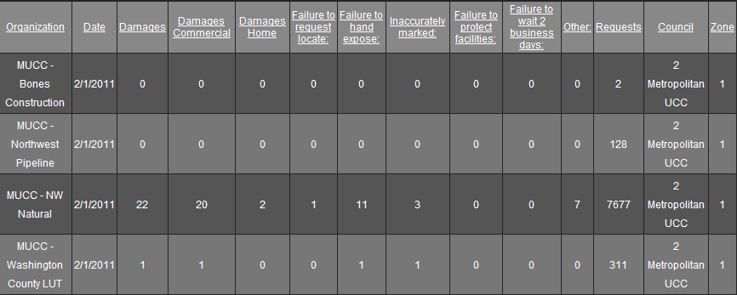

March 2011: Four submittals for damages…
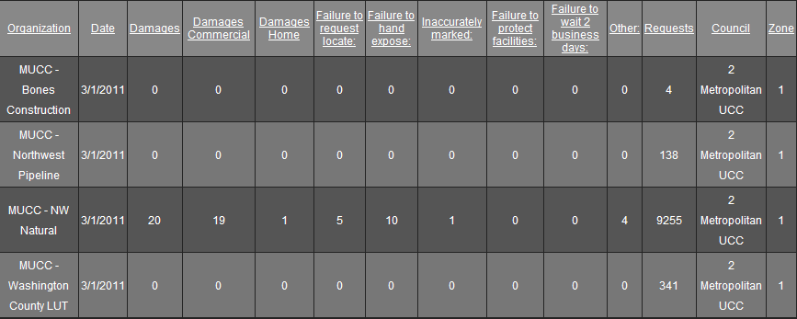

April 2011: Four submittals for damages…

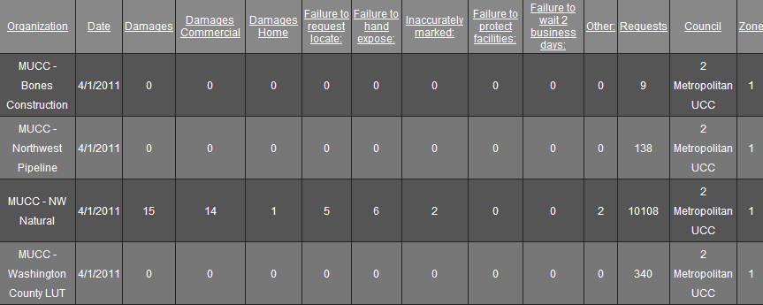

May 2011: Three submittals so far…Don’t forget to get your reports in!
