Meeting Minutes

Metropolitan Utility Coordinating Council
MUCC, C/O Jarrod Morrison, 3700 SE 17th Ave, Portland, OR 97202

September 28th, 2011
Our next meeting will be October 26th, 2011
At the Elmers at 10001 NE Sandy Blvd.
http://www.bing.com/local/details.aspx?lid=YN720x12481953&qt=yp&what=elmer's+restaurant&where=Portland%2c+Oregon&s_cid=ansPhBkYp02&mkt=en-us&q=elmer's+restaurant+portland+or&FORM=LARE
(Control +Click mouse on link for Map Directions & Menu)

ATTENDEES: See attached listing.
__________________________________________________________________________________________________

REPORTS:

Treasurer’s Report for July 2011:
M Bank Golf Fund Golf Fund Rodeo Visa
(Checking) (Savings)
Beginning Balance $ 4,121.49 $ 1,121.81 $ 5.00 $ 0.00 $ -
Ending Balance $ 4,321.49 $ 1,121.81 $ 5.00 $ 0.00 $ -

One transaction – Deposit of $200 for golf hole sponsor check

Payments / Purchases / Income:
As a non-profit organization, all monies collected go for supplies/events to educate the public!
Our ending balance (all accounts) must be under $5,000 at the end of the year or we will have to pay taxes.

Damage Report: See the end of the minutes. WE are doing great with our reporting! Keep it up!

We must have five (5) entities reporting monthly – be sure to report your damages in a timely manner!
The Common Ground Alliance (CGA) encourages the use of their Damage Information Reporting Tool (DIRT). You can check this out at www.cga-dirt.com

P&E Report (Publicity and Education):

P&E General: Send your ideas to Don Patterson (dwp@nwnatural.com) and Anita Floyd (anita.floyd@qwest.com)

New:
No one from P & E was present.

Old:
The Lars Larsen interview went well and was heard by several of our members. Adam Franco (One Call Concepts) and Anita Floyd (CenturyLink/OUNC) were there and gave out some very good information. They are hoping to meet with Lars again in April – Safety Awareness Month.
From Tracey Oberacher (Clackamas River Water) – He has been talking to managers at some of the local Garden Centers. Some are interested in sharing our handouts for the public in their stores or at their classes that they give.
It was suggested that HOA’s, Church groups and other groups that do community events/gatherings/plantings be made aware of the 811 Dig Laws
Anita Floyd suggested that if there are any concerns with the wording or have questions or suggestions on the OAR’s, to please contact Jennifer Carter w/ Emery & Son’s @ Jennifer@emeryandsons.com, as they are being worked on at this time.
Don Patterson is working hard to find local media venues to get the word out. If you have any contacts at your local newspapers or radio stations, please pass on that contact info to him.

We are looking for local community sponsors! Please talk to any of our local vendors who sell/rent items where it would benefit us and the public to have our handout in the store. If the store will agree to have our handouts available for the public, pass their contact info on to Don to get it set up. If the store wants to make a donation for a giveaway at one of the events that we attend, that would be great as well, but it is not required. We mostly want to get our handouts into their stores so the public has access to it!
An event that is coming up that we can discuss attending is the Mississippi Street Fair. More details to follow.
See Upcoming Events / Meetings for the Locator Training Sessions this year.
There is a lot happening these next few months. They are planning to spend about $40,000 next year toward radio advertising.
Columbia Gorge/Hood River areas are planning radio ads to promote 811 as well as using small newspaper ads. Don Patterson has checked into our local area and found that there is one radio company that owns about a dozen smaller newspapers in the local region. We can run a single ad (3.5” x 4” in color) in these local papers for just $145/month. Don Patterson will put together a proposal for our information and vote for the next MUCC meeting. We are thinking of doing several months of advertising this summer/fall and perhaps 6 months of advertising next year.
OUNC is looking for new promotional items.
Requests for cards/pens/hats/other items are being downsized because OUNC doesn’t want to run out of inventory. Please only order what you really need.

811 CAMPAIGN: (No new information this month)
Home Depot is breaking out in the western region. Go into your local Home Depot and if you do not see the 811 info, ask at the Contractors desk.
In Oregon, the stores will carry Key Chains for all equipment and color code cards. The “Associates” who will be trained to answer questions will have patches on their aprons.
The OUNC meets the 2nd Wednesday of the month at the One Call Center in Portland.
You may go to www.call811.com website for more information.
____________________________________________________________________________________________________________

Upcoming Events / Meetings:

REGIONAL LAW UPDATE: The Coos Bay event has been postponed (indefinitely). There was a roadblock trying to get the lists of people for attendees. Updates will follow as they come in.
_______________________________________________________________________________________

OLD BUSINESS:

RAA - Next hearing date is October 14th from 8am to 3pm
Hearings are at the PUC Building at 550 Capitol St NE, Salem. Be sure to bring change for the parking meters if you attend. The OUNC has asked Michael Thompson to put together a summary of the RAA hearings. This would benefit the local councils to help promote education to the local contractors in the areas where infractions are the highest.

If you know of any websites that could benefit by having a link to our website, please pass the website on to Don Patterson to check it out. Getting our link onto other websites is a good way to be visible online and can reach many people.
Williams Pipeline has a project that will be extending from Oregon City to Molalla. It is a new 16’ & 20” line that will run 14 ½ miles.
Washington County said the City of Beaverton will be installing a 16” waterline from 153rd to Murray and north on Murray. This will take place in the next 3-4 weeks.
Jarrod would like to form a committee to review the old Bylaws (adopted in March 1998) and bring them up to date.
Adam Frank with OUNC told us that the disclaimer has been added now regarding the use of contact information that Jarrod Morrison talked about in May.
Gary Hyatt reminded everyone to pass along the reminder to their companies, that when calling in locates to please call in specific marking instructions rather that requesting to locate the entire lots.
Don Patterson announced the beginning of the planning for the Joint States Meeting next year that will be hosted in Oregon by the OUNC/P&E Committee. Don is looking for ideas for a theme. If you have any ideas please send them to Don Patterson @ dwp@nwnatural.com. They are shooting for the meeting to be held in September 2012 in Seaside, OR.
One Call #’s are still down 6%from last year!
The change from Qwest to CenturyLink has taken effect. Anita Floyd will distribute a notice with the exact logo that will be used out in the field. She’s pretty sure it will be “CTL” Some ideas were mentioned of how to get the “811” advertised by the utility companies to the home owners, by either a flyer in the bills or a stamp on the envelope, some utility representatives said they would ask around to see if there was something that could be done.

REMINDER…Send your current and/or upcoming projects to Marta Padilla at marta.padilla@locatinginc.com and they will be attached to the Minutes e-mail so everyone will know where projects are or will be happening and your company can schedule accordingly.

811 Locate Requesting is available 24/7! Don’t wait until first thing Monday morning to call in your locates – you’ll find the lines are packed with everyone else calling at the same time! Call Saturday or Sunday if you want to get your request in early. Still expect two (2) business days for the locates to show up!
Should you encounter an un-located utility while excavating – stop digging, call 811 to report it immediately, determine that there is no immediate danger, and you can continue working (if your project allows) using extreme care in the affected area. See Page 23 (5) in the Standards Manual.

NEW BUSINESS:

The process of damage reporting was discussed. Gary Hyatt asked that companies submit your damages in order to receive the $1000 back. Jarrod explained how the reporting can be used as an educational tool & how we could receive grants for the educating.

Ralph Reisbeck reported that the Clackamas Town Fair was a great success, despite that the fair was quite smaller than in the past. Gary reported that quite a bit of people stopped by the booth, that weren’t familiar with “811” and were able to learn about it.

Jarrod announced that soon the City of Keizer is to put a huge “811” logo on the City of Keizer Water Tower off of I-5, which will be great advertisement.

No one volunteered to be the Nominating Committee for the MUCC Board Chair positions, so it will be Gary Hyatt & Jarrod Morrison. Gary & Jarrod will be contacting everyone on the distribution list asking if they would be interested in the Vice President/Treasures office. Nominations will be held in the October meeting & Elections will be in November. If you would like to nominate someone or volunteer yourself for one of the positions, please send your nomination/volunteer information to Gary Hyatt gfh@nwnatural.com, Jarrod Morrison Jarrod.Morrison@pgn.com, and Marta Padilla marta.padilla@locatinginc.com.
There are also several offices that are vacant. All the offices we have are as follows: P&E, Standards, Damages, APWA, One Call and Programs. If you would like to help out with any of these offices, contact Gary, Jarrod and Marta.

REMINDER…Send your current and/or upcoming projects to Marta Padilla at marta.padilla@locatinginc.com and they will be attached to the Minutes e-mail so everyone will know where projects are or will be happening and your company can schedule accordingly.
______________________________________________________________________________________

Remember – CCC – Communicate, Coordinate, And Cooperate!
______________________________________________________________________________________________________________________________________________

VOLUNTEERS NEEDED: As you have read, there are a variety of opportunities for all to volunteer and help spread the word of our Call before You Dig message. These are great opportunities to network and get to know each other better. Take advantage of these opportunities and make new friends. If you are able, make yourself available to be on a committee or to volunteer on any of the upcoming projects and events these next couple of years. This is what this Council is all about and how we strive to be excellent!
_______________________________________________________________________________________
Oregon Utility Notification Center  www.digsafelyoregon.com | Oregon Utility Coordinating Council  www.oucc.net

Check out the websites for info on the Oregon Dig Law, upcoming events and on your local Council(s).
There are new changes to the website – check them out.
Also available: see information on Best Practices at www.commongroundalliance.com
_______________________________________________________________________________________

Respectfully submitted by Marta Padilla.
_______________________________________________________________________________________
The next meeting: Date: Wednesday October 26th, at 11:30am
Location: Elmers at 10001 NE Sandy Blvd
http://www.bing.com/local/details.aspx?lid=YN720x12481953&qt=yp&what=elmer's+restaurant&where=Portland%2c+Oregon&s_cid=ansPhBkYp02&mkt=en-us&q=elmer's+restaurant+portland+or&FORM=LARE

The 2011 schedule is the 4th Wednesday of each month except November

(the week before Thanksgiving this year) and December (no meeting).

October 26th November 16th Dec - No meeting

The 2012 schedule is the 4th Wednesday of each month (November is

the week after Thanksgiving this year) and December (no meeting).

January 25th February 22nd March 28th April 25th
May 23rd June 27th July 25th August 22nd

September 26th October 24th November 28th Dec - No meeting

2011 MUCC Executive Board
MUCC, C/O Jarrod Morrison, 3700 SE 17th Ave, Portland, OR 97202

PRESIDENT: Gary Hyatt, NW Natural, 220 NW 2nd Ave, 3rd Floor, Portland OR 97209

Office - (503) 226-4211 ext 4320, gfh@nwnatural.com

VICE PRESIDENT / TREASURER: Jarrod Morrison, Portland General Electric, 3700 SE

17th Ave, Portland, OR 97202, Office – (503) 736-5505, Cell - (503) 849-7043
Fax - (503) 736-5500, Jarrod.Morrison@pgn.com

SECRETARY: Marta Padilla, Locating Inc, 6601 NE 78th Ct, Portland OR 97218
Office – (503) 255-4634, marta.padilla@locatinginc.com

PUBLICITY & EDUCATION: Don Patterson, NW Natural, 220 NW 2nd Ave, 3rd Floor

Portland OR 97209, Office - (503) 226-4211 ext 4387, Cell – (503) 806-0845
Fax – (503) 273-4822, dwp@nwnatural.com

DAMAGE CHAIR: Shannon Davis, Qwest, 100 NW Kearney Ave, Bend, OR 97701

Office – (541) 388-5296, Fax – (541) 388-5269, Shannon.Davis@qwest.com

2011 MUCC PAID MEMBERS

As of 04-14-11
Advantage Drilling LLC  Bones Construction, Inc.  BP Olympic Pipeline  City of Gladstone  City of Gresham, OPS Center  City of Hillsboro  City of Lake Oswego  City of Oregon City  City of Sandy  City of Tualatin  Clackamas County  Clackamas River Water | Comcast  Dirt & Aggregate Interchange, Inc  Ditch Witch Northwest  Gonzales Boring & Tunneling, Inc  Henkels & McCoy  James W Fowler Co.  Knife River  Linescape  Locating, Inc  Loy Clark Pipeline  Multnomah County  North Sky Communications | Northwest Pipeline  NW Natural  ODOT  Old Castle Precast  Pacificorp/Pacific Power  Port of Portland  Portland General Electric  Qwest Communications  Sunrise Water Authority  Superior Fence Construction  Washington County LUT

Damage Report: In 2011 we must have a minimum of five (5) damage reports per month.
Please submit your damages within 30 days.
The following is from the Website http://oucc.net/ taken October 18, 2011.

July 2011: Seven submittals for damages…
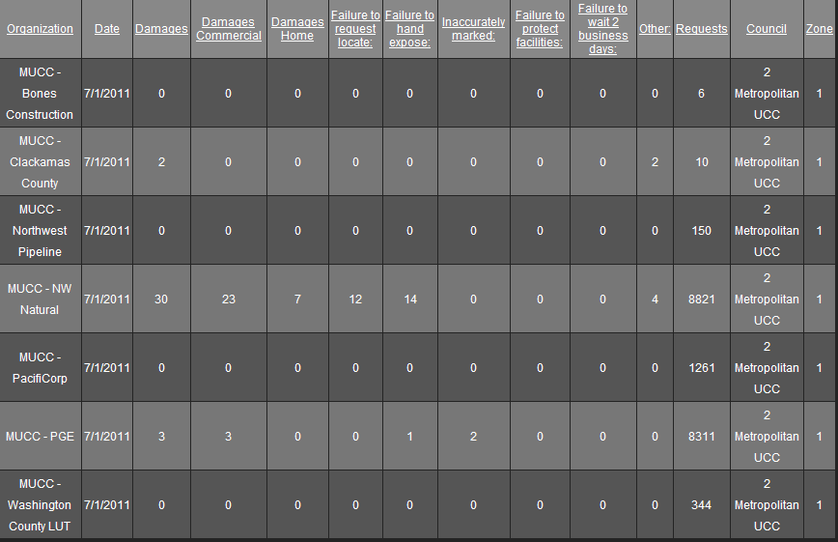

August 2011: Five submittals for damages…
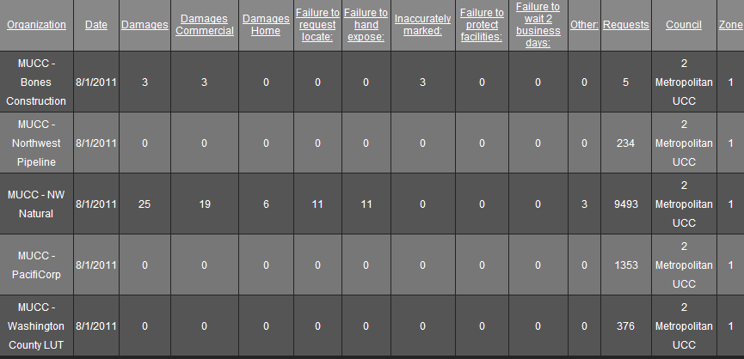

September 2011: Two submittals so far……….