Meeting Minutes

Metropolitan Utility Coordinating Council
MUCC, C/O Jarrod Morrison, 3700 SE 17th Ave, Portland, OR 97202

February 24, 2010
Our next meeting will be March 24, 2010 at the Village Inn in NE Portland

ATTENDEES: See attached listing.
_____________________________________________________________________

REPORTS:

Treasurer’s Report for February 2010: Several transactions this month – all related to the 2010 Yard, Garden and Patio show.

M Bank Golf Fund Golf Fund Rodeo Visa
(Checking) (Savings)
Beginning Balance $ 3,476.77 $ 1,121.81 $ 5.00 $ 0.00 $ -
Ending Balance $ 3,307.77 $ 1,121.81 $ 5.00 $ 0.00 $ -

Payments / Purchases / Income:
As a non-profit organization, all monies collected go for supplies/events to educate the public!
Our ending balance (total of all accounts) must be under $5,000 at the end of the year or we will have to pay (very high) taxes.
There are opportunities coming up where we can get some good exposure to the public. See the P & E report.
It’s time to get the Golf Committee together. Please let Jarrod know if you are interested on being on the Committee.
The Membership Dues Invoices are being sent out this month. Please be sure to get your payments in so we can get the word out! Dues help fund our attendance at special events like the Yard, Garden and Patio show, the Golf Tournament and other public events.
Our Dues to the OUCC will be $650 this year. ($50 for website maintenance, and $600 which relates to the population that the MUCC serves.)

Damage Report: See the end of the minutes.

P&E Report (Publicity and Education):

P&E General:
New:
The Yard, Garden & Patio show went very well – there were lots of questions asked by the public, and stories were shared. We drew names for the $50 Gift Cards from Home Depot and our winners are:
Laura Spurrell of Tualatin OR
Pam Drotar of Hillsboro OR
Scott Cartwright of Lake Oswego OR and
Ruley Issac or Dayton OR Congratulations to all of them!
We would like to thank all of the volunteers who helped to make the YGP a huge success – Thank You!!
At the P&E meeting for the OUNC they are looking for new promotional items. Send your ideas to Don Patterson (dwp@nwnatural.com).

Old:
Don Patterson has checked into the Chico Bag – a reusable bag in a pouch – as a handout. It can be printed with our logo and a minimum order costs $1,700/ 500 bags. We should consider going in with other UCC’s on an order like this. This bag is manufactured out of Chico California. Another suggestion was magnetized letter openers with the one-call number on them.
We are looking at different products for the smaller public events (those that last only a few hours).
Don suggested that we could participate in small community parades with our banner.
Clackamas Community College is open to presenting information about one-call at their landscaping classes and would like handouts. Other Community Colleges in the area should be contacted about also including the info in their classes.
Please send any ideas to help get the word out to Don Patterson (dwp@nwnatural.com) or to Anita Floyd (anita.floyd@qwest.com).

811 CAMPAIGN:
Home Depot is laying off people. The 811 campaign for Home Depot is on hold. Jarrod Morrison will find out if it will be revived.
The magnets are being updated to look more like the color code cards. Both are available.
You may go to www.call811.com website for more information.
______________________________________________________________________________________

REGIONAL LAW UPDATE: Has been cancelled until spring of 2010 and will be held in Coos Bay, May 13. It is free, includes lunch, and will have lots of SWAG. The local councils will be asked to recommend contractors for the Golden Shovel Award for exceptional prevention of damages. Send your recommendations to Gary Hyatt (gfh@nwnatural.com). They will be relying heavily on the councils to volunteer. Sign up will be at www.digsafelyoregon.com closer to the time of the events.
__________________________________________________________________________________________________________

Upcoming Events:

2010 GOLF TOURNAMENT:
The date is set for July 23rh, 2010 with a 7:30 shotgun start. Start thinking about joining the fun – either by playing or by volunteering at the event! The Committee will be meeting soon.

2011 LOCATE RODEO:
There will not be a Locate Rodeo IN 2010. The OUNC agreed to make it a biennial event.
_____________________________________________________________________________________

OLD BUSINESS:

Very few complaints have been filed recently. PGE is going to start, as they have had some damages recently. Gary encouraged everyone to file complaints, as they are the best way to get the contractor’s attention.

The issue of the meeting location was discussed. There was a consensus that the current location is centrally located, and it would be better to stay in the same place consistently. Many members were in favor of adding quarterly lunches in outlying areas, for people who cannot make it to the breakfast time or location.

APS contracted through DEA to work with BPA on their I-5 Reinforcement Program from Troutdale to Castle Rock. They are looking at utilities within 300’ of their facility. DEA is doing several projects for BPA. BPA is looking at different routes. They will probably start construction in the next year.

There is no locator certification. OUNC is working on some training.

Several members have had problems with not being able to get through to the phone number/person who called in the locate ticket. Gary suggested getting on the Construction Contractor Board or Landscaper Contractor Board web sites to get phone numbers.

NEW BUSINESS:

Sign Installations: Josh Hockenjos from Cokes Posting Service needs flags to show the locations for locating for sign installations. He is pushing for Seller’s Agents to place the flags at the locations the For Sale signs will be located prior to calling in the locate. He is trying to get the many Realtors to use credible sign companies who are obeying the laws and calling for locates.

One of the many questions brought up at the Yard, Garden and Patio Show was “who do we call for private locating?” There was a suggestion that perhaps we could have a list generated from the Yellow Pages to have available for the public or links to get them to the best web pages to search for Underground Utility Locators.
______________________________________________________________________________________

Remember – CCC – Communicate, Coordinate, Cooperate!

VOLUNTEERS: As you have read, there are a variety of opportunities for all to volunteer and help spread the word of our Call before You Dig message. These are great opportunities to network and get to know each other better too. Take advantage of these opportunities and make new friends. If you are able, make yourself available to be on a committee or to volunteer on any of the upcoming projects and events these next couple of years. This is what this Council is all about and how we strive to be excellent!
______________________________________________________________________________________

OUNC OUCC
Oregon Utility Notification Center Oregon Utility Coordinating Council
www.digsafelyoregon.com www.oucc.net

Check out the websites for info on the Oregon Dig Law, upcoming events and on your local Council(s).
There are new changes to the website – check them out.
Also available: information on best practices at www.commongroundalliance.com
______________________________________________________________________________________

Respectfully submitted by Dawn Haase.
______________________________________________________________________________________

The next meeting:
Location: Village Inn at 1621 N.E 10th Ave in Portland
Date: Wednesday, March 24th at 7:30am

The 2010 schedule is the 4th Wednesday of each month except November

(the week before Thanksgiving) and December (no meeting).

January 27th February 24th March 24th April 28th
May 26th June 23rd July 28th August 25th

September 22nd October 27th November 17th Dec - No meeting

2009 MUCC PAID MEMBERS

As of 07-15-09

Applied Professional  Bones Construction, Inc.  City of Fairview  City of Gladstone  City of Gresham, OPS Center  City of Happy Valley  City of Hillsboro  City of Lake Oswego  City of Milwaukie  City of Oregon City  City of Tualatin  Civil Works NW Inc  Clackamas County | Comcast  Dirt & Aggregate Interchange, Inc.  Ditch Witch Northwest  Emery & Sons  Excel Excavation Inc  Henkels & McCoy  Knife River  Linescape  Locating Inc.  Loy Clark Pipeline  Multnomah County  North Sky Communications  Northwest Earthmovers, Inc. | ODOT  Oldcastle Precast  PacifiCorp / Pacific Power  Port of Portland  Portland General Electric  Qwest Communications  Robinson Bros Const Inc  Sunrise Water Authority  Tri-State Construction  Tualatin Valley Water District  Verizon  Washington County LUT  Williams Pipeline

2010 MUCC Executive Board
MUCC, C/O Jarrod Morrison, 3700 SE 17th Ave, Portland, OR 97202

PRESIDENT:  Gary Hyatt  NW Natural  220 NW 2nd Ave, 3rd Floor  Portland OR 97209  Office - (503) 226-4211 ext 4320  gfh@nwnatural.com | VICE PRESIDENT / TREASURER:  Jarrod Morrison  Portland General Electric  3700 SE 17th Ave  Portland, OR 97202  Office - 503-736-5505  Cell - 503-849-7043  Fax - 503-736-5500  Jarrod.Morrison@pgn.com
SECRETARY:  Dawn Haase  Clackamas County DTD Eng  150 Beavercreek Rd  Oregon City OR 97045  Office – (503) 742-4682  Cell – (503) 789-5728  Fax – (503) 742-4659  dhaase@co.clackamas.or.us | PUBLICITY & EDUCATION:  Don Patterson  NW Natural  220 NW 2nd Ave, 3rd Floor  Portland OR 97209  Office - (503) 226-4211 ext 4387  Cell – 503-806-0845  Fax – (503) 273-4822  dwp@nwnatural.com

DAMAGE CHAIR:

Shannon Davis

Qwest

100 NW Kearney Ave
Bend, OR 97701

Office - 541-388-5296

Fax - 541 388-5269
Shannon.Davis@qwest.com

Damage Report
In 2010 we must have a minimum of three (3) damage reports per month. Please submit your damages within 30 days. From the Website http://oucc.net/ As of March 16, 2010:

December 2009: Eight submittals for damages…
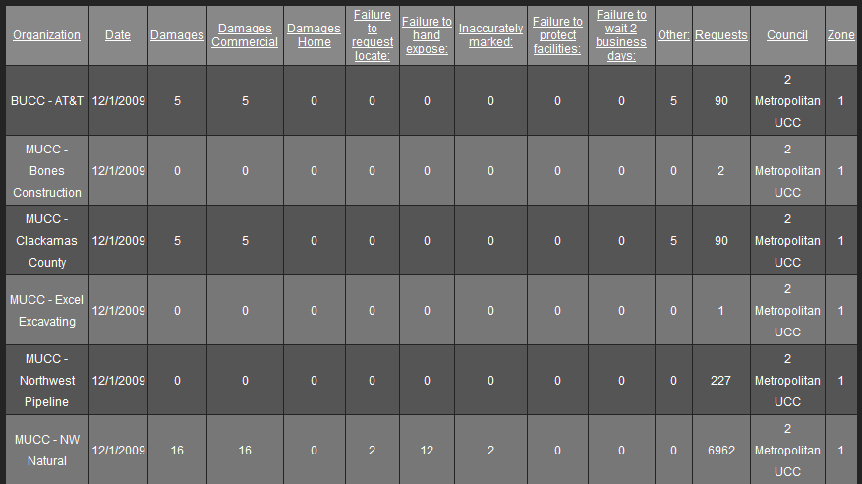
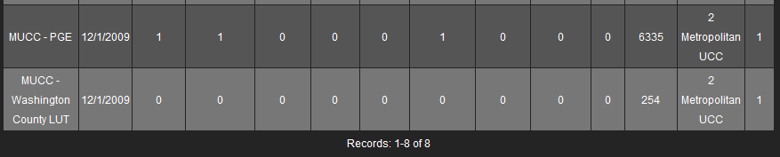

January 2010: Six submittals for damages…
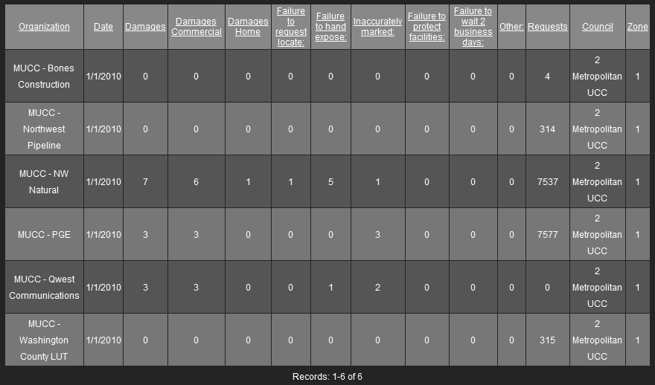

February 2010: Only two submittals so far – Don’t forget to report your damages!
