Meeting Minutes

Metropolitan Utility Coordinating Council
MUCC, PO Box 12001, Portland, OR 97212-0001

November 19, 2008
Our next meeting will be January 28th, 2009

ATTENDEES: See attached listing.
______________________________________________________________________________

REPORTS:

Treasurer’s Report for June 2008:

M Bank Golf Fund Golf Fund Rodeo Visa
(Checking) (Savings)
Beginning Balance $ 6,179.51 $ 2,168.85 $ 5.00 $ 875.00 $ -
Ending Balance $ 5,988.75 $ 2,484.61 $ 5.00 $ 2,470.00 $ -

Payments / Purchases:
No changes to the accounts this past month.

Dues for next year will remain the same as this year - $75 for non-utilities and small water districts, and $125 for major utilities. Billing will take place around February.

Forty (41) members have paid their dues this year. An audit committee of Christine, Mike (Oleson) and Duffy met for about 30 minutes after the October MUCC meeting to do an audit and everything tallied up.

We will be donating $1500 to the Ronald McDonald House from the proceeds of the golf tournament. This is $500 more than last year and $700 more than the year before! Jarrod will call and set up an appointment to tour the facility and deliver the check. The annual report for RMH listed MUCC with a heart, meaning we have 3 years of donating to their foundation. We will send out a notice with the date to see who would like to participate in the tour.
________________________________________________________________________________

Damage Report: (located at the end of these minutes)

Make sure to report all your damages each month directly to the website http://oucc.net under Damages. It is suggested that you report your damages within 30 days of the month you are reporting for with final figures as you can add original information but you cannot edit it on the website. If you have not signed up – it is real easy and only takes one minute!

These reports let us know how the damages are occurring and at what percentages. Please report your damages every month!

If your agency doesn’t care for the way your damages are reported, please contact Stephanie Baxter (website owner).

OUNC continues to sponsor a program to encourage participation for local Councils to submit monthly damage reports. OUNC is offering cash incentives monthly and quarterly to those Councils who report their damages to them. The incentive is up to $1,200. We need to submit our Officers List, and we must have a minimum of five reports monthly in order to qualify for these incentives. We had only three for September and none yet reported for October. Please go back and enter for your company if you haven’t already done so. Another part of the incentive is to add one new member to our Council each year. Last year we added four new members. We will need one additional member this coming year to qualify for the $1,200. Gary Hyatt will check with United Pipe to become a member and will check with the local Engineering firms as well to attend or be members.

Each monthly damage report will now be attached to these minutes. We need to maintain at least 5 contributors to receive the seed money from OUNC. Next year we will be required to add one more damage contributor and one more MUCC member to continue to receive the money. Jarrod will contact the PGE landscape contractor for this.
_________________________________________________________________

Standards Manual:

The Standards Manual is completed and is available. It can be ordered from the OUNC website as can any and all P & E material. Also, you can go to digsafelyoregon.com for supplies. Jamie has a box of the manuals to hand out, and Jarrod has another box. Contractors can also contact Gary Hyatt for copies, (gfh@nwnatural.com, or 503-226-4211 ext. 4320). If large quantities of manuals are requested it will need to be approved by an OUNC board member.

__________________________________________________________________

P&E Report (Publicity and Education):

CARD HOLDERS, CALENDARS AND COLOR CODE CARDS. Calendars are now available from Pacific Marketing, and Gary Hyatt has the order form. Jarrod has cards and card holders and will bring to the next meeting for Geoff. We need to get these out to the rental shops around the area.

YARD GARDEN AND PATIO SHOW. 2009 Yard, Garden & Patio Show (Feb 27 – March 1 2009) will be coming up soon. Dawn has the new application and has re-applied. As information is received, it will be sent out. Dawn will be making a sign-up sheet to match the number of tickets we will receive from OAN (Oregon Association of Nurseries) for the show and sending it out to everyone. Please call Dawn to sign up at that time.
- OUNC will be paying half of the price for the booth to all UCC’s that want to participate in shows of this nature to get the word out.
- It was suggested that the MUCC put money toward the $3 “Call Before You Dig” T-shirts for giveaways at the YG&P Show this spring.

811 CAMPAIGN: You may go to www.call811.com website for more information. There are materials available to any company wanting them for FREE, contact Gary Hyatt with the number wanted, or go to http://www.digsafelyoregon.com/. Gary and Patty will arrange to get on the NUCA agenda to deliver this message. There are still t-shirts available; check the website as you can’t afford not to buy them!

REGIONAL LAW UPDATE: The Update took place November 13 from 8 AM to 3 PM in Albany, for a day long training seminar on Oregon Dig Law and Damage Prevention. Over half of the attendees were contractors. CEU’s were available for most of the attendees in a variety of utility works. Two more seminars are planned for the Portland area in 2009. They are free, include lunch, will have lots of SWAG, and CEU’s will be available for most utility companies. The local councils will be asked to recommend contractors for the Golden Shovel Award for exceptional prevention of damages. They will be relying heavily on the councils to volunteer. Sign up will be at www.digsafelyoregon.com closer to the time of the events.

As soon as the dates for 2009 are set, announcements will be made to recruit for help. There was a meeting Sept. 24 to discuss the premier speaker.
____________________________________________________________

OLD BUSINESS:

RAA hearing: There is a hearing scheduled for Friday, November 21st at PUC from 8:30 to 12:30. There are five cases to be heard; three from NWNG, one from Cascade Natural Gas, and one from Avista Utilities. Clackamas County has 2 cases to bring up and Gary Hyatt will help them fill out the form. The form can be found on the website under RAA process. The OUNC encourages attendance at the RAA hearings to see what the process is. It is very educational.

Pre-design survey locates were discussed. Communication with the facility operators for as builts and locates should occur. On the locate ticket it has an area to mark “as builts” and that gets passed on to the facility operator. Please stamp on as built, “Call Before You Dig”. The problem appears to be receiving as builts but not getting paint on the ground. Pre-design survey locates are covered on page 21 of the Standards Manual, and states that, “…the operator shall…” With respect to the standards manual, there is a new item in this issue on page 17 (number 4).

Another topic brought up was Washington County requires (understandably) that core holes or potholing be restored back to the way it was, and needs to use CDF. They also require a permit to pothole. The County can use www.searchandstatus.com to search as far back as 2-1/2 years to see who requested locates for the road in question, and follow up with them to restore it to specifications.

In lieu of calling 911, the Non-Emergency Response phone numbers by County are:
Washington County 503) 629-0111
Multnomah County (503) 823-3333
Clackamas County (503) 655-8211

Call Before You Dig T-shirts: STILL AVAILABLE – CALL JAMIE STENCIL

Clackamas County will be working 4-10 hour days starting on November 3rd with office hours of Monday through Thursday 7 am to 6 pm with the lobby doors closing at 5:30. They have moved to Oregon City to the Red Soils area at 150 Beavercreek Road in the Development Services Building. For sustainability purposes, they do not want anyone in the building on Fridays, Saturdays, or Sundays. Some inspectors will be available on Fridays for emergency inspections.

A Merchant Services transaction report was proposed. Some good suggestions were made to improve upon it, and will be brought to next meeting.

Patty spoke of the Greater Portland Construction Partnership Group meeting with about 75 people attending. It consists of large and small contractors meeting quarterly to discuss issues. This meeting was on crane safety. The dues are $250/ year. The purpose is to educate and communicate for a greater cause to minimize accidents. Patty will get me contact information, and MUCC will look into speaking at and sponsoring their appetizer (?) for an upcoming meeting. Their next quarterly meeting is at the Convention center in either December or January.
__________________________________________________________________

From Jamie: The Yamhill MWUCC is looking into sponsoring a Fishing Derby in 2009 (instead of a Golf Tourney). They will be contacting neighboring UCC’s (including us) to co-sponsor this event. It will take place at Vernonia Lake in Vernonia with tagged fish and a variety of categories to win a prize in. I’m sure volunteers will be needed for this fun event!
__________________________________________________________________

NEW BUSINESS:

Officers for 2009 MUCC board have been chosen -

For the position of President, Gary Hyatt has volunteered.
For the position of Vice President/Treasurer, Jamie Stencil has volunteered.
For the position of Secretary, Dawn Pike has had her arm twisted again! (Thanks Jarrod!) ☺

A big welcome (and thank you) to our new Officers!

Sheri explained the duties of each position as follows:
Secretary: Take notes and prepare minutes and attachments to send out to the Council members.
Can be involved with the events that are sponsored by MUCC.
Vice Pres. /Treasurer: Balance Accounts, prepare the Treasurers Report, back up the President
and/or Secretary when they are absent, help with the events that are sponsored by MUCC,
download the Damage Report from the OUNC website.
President: Chair the monthly meetings, help with the events that are sponsored by MUCC.
______________________________________________________________________________

Gary has suggested a couple of ideas for the next year, more discussion will follow at the next meeting.

1st we should be submitting monthly reports on any ongoing projects.
2nd The MUCC should have the Utility companies submit contractors’ names to us who could use a refresher course in the One Call Laws and we (MUCC) would treat them to an on-site lunch and lessons in safety and the laws.
Clackamas County will be starting a large project this next year. 172nd Avenue will be reconstructed between Sunnyside Road to the south to Armstrong Circle, and an extension from Armstrong Circle to Hwy 212 will be newly constructed. This project has just gone to bid and is expected to start in January 2009.

Food to digest: As you can read there are a variety of opportunities for all to volunteer and help spread the word of our Call before You Dig message. These are great opportunities to network and get to know each other better too. Take advantage of these opportunities and make new friends. If you are able, make yourself available to be on a committee or to volunteer on any of the upcoming project(s) and events these next couple of years. This is what this Council is all about and how we strive to be excellent!
__________________________________________________________________

Oregon www.digsafelyoregon.com Oregon www.oucc.net
Utility Utility
Notification Coordinating
Center Council

Check out these websites for information on the Oregon Dig Law, upcoming events and information on your local Council(s).

Also available: information on best practices at www.commongroundalliance.com.
__________________________________________________________________

Respectfully submitted by Dawn Pike.

The next meeting:
Location: Village Inn at 1621 N.E 10th Ave in Portland
Date: Wednesday, January 28th at 7:30am

The 2009 schedule is as follows:
4th Wednesday of each month except November (early) and December (no meeting)

January 28th February 25th March 25th April 22nd
May 27th June 24th July 22nd August 26th
September 23rd October 28th November 18th Dec - No meeting

2009 MUCC Executive Board
MUCC (new) Mailing PO Box address is: PO Box 12001, Portland, OR 97212-0001

PRESIDENT:  Gary Hyatt  NW Natural  220 NW 2nd Ave, 3rd Floor  Portland OR 97209  Office - (503) 226-4211 ext 4320  gfh@nwnatural.com | VICE PRESIDENT / TREASURER:  Jamie Stencil  Comcast  9605 SW Nimbus Ave  Beaverton OR 97008  Office - 503-605-6158  Cell - 503-572-2242  Fax - 503-605-6233  Jamie_Stencil@cable.comcast.com
SECRETARY:  Dawn Pike  Clackamas County DTD Eng  150 Beavercreek Rd  Oregon City OR 97045  Office – (503) 742-4682  Cell – (503) 789-5728  Fax – (503) 742-4659  dawnpik@co.clackamas.or.us | PUBLICITY & EDUCATION:  Gary Hyatt  NW Natural  220 NW 2nd Ave, 3rd Floor  Portland OR 97209  Office - (503) 226-4211 ext 4320  gfh@nwnatural.com

DAMAGE CHAIR:

Shannon Davis

Qwest

100 NW Kearney Ave
Bend, OR 97701

Office - 541-388-5296

Fax - 541 388-5269
Shannon.Davis@qwest.com

2008 MUCC PAID MEMBERS
as of 11-19-08
1st Choice Traffic Control | Locating, Inc.
 | Loy Clark
Applied Professional Services
 | Moore Excavation, Inc
Bones Construction, Inc. | Multnomah County
City of Fairview | Northwest Earthmovers, Inc.
City of Forest Grove | North West Natural
City of Gladstone
City of Gresham, OPS Center | ODOT
City of Happy Valley | OldCastle Precast
City of Hillsboro
City of Lake Oswego | PacifiCorp / Pacific Power
City of Oregon City | Portland General Electric
City of Sandy | Portland General Electric
City of Tualatin
Civil Works NW, Inc. | Qwest
Clackamas County
Comcast | Sunrise Water Authority
Dirt & Aggregate Interchange, Inc. | Tri-State Construction
Ditch Witch | Tualatin Valley Water District
Emery & Sons | Verizon
Henkels & McCoy | Washington County LUT
 | Williams Pipeline
James Fowler

Damage Report
In 2009 we must have a minimum of five (5) damage reports per month. Submit your damages within 30 days.

From the Website http://oucc.net/ As of 11-19-08:

September 2008: THREE SUBMITTALS FOR DAMAGES
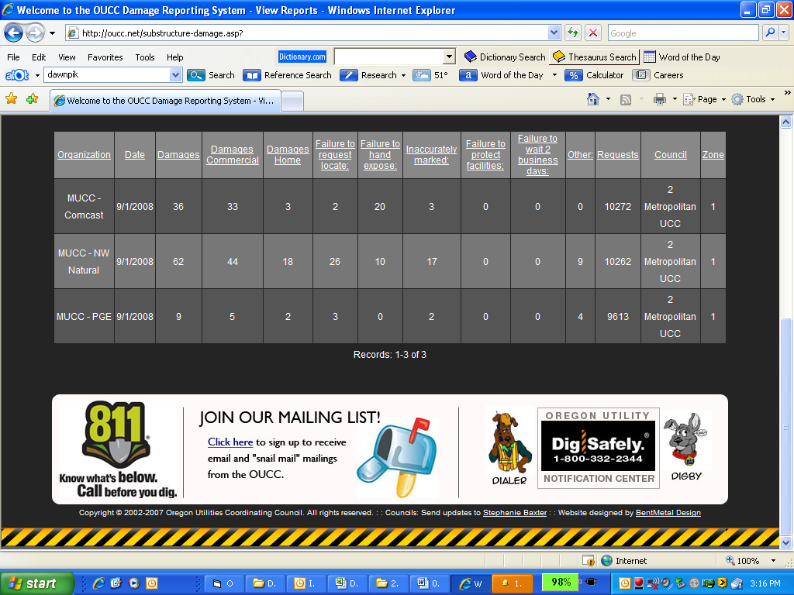

October 2008: NO RECORDS – EVERYONE PLEASE SUBMIT YOUR DAMAGES!!!
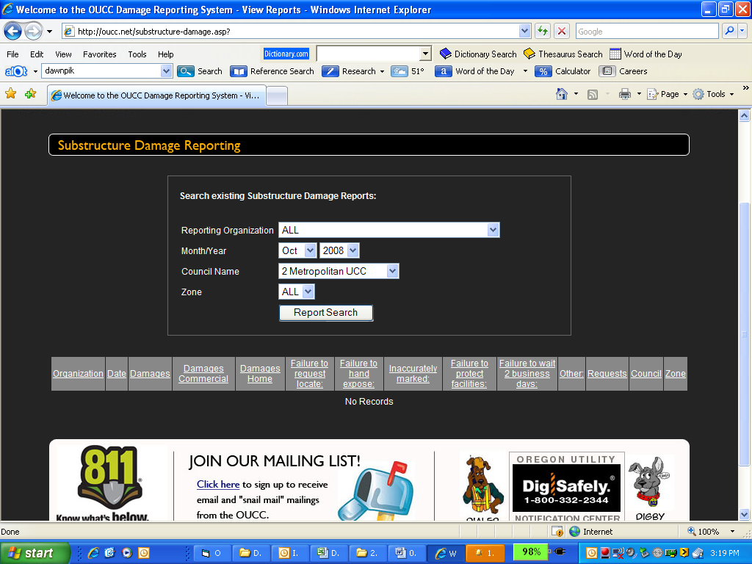

November 2008: ONE SUBMITTAL FOR DAMAGES – GET YOUR DAMAGES REPORTED!!!
