Meeting Minutes

Metropolitan Utility Coordinating Council
MUCC, PO Box 12001, Portland, OR 97212-0001

May 27th, 2009
Our next meeting will be June 24th, 2009

ATTENDEES: See attached listing.
__________________________________________________________________________________________________________________

REPORTS:

Treasurer’s Report for June 2008:

M Bank Golf Fund Golf Fund Rodeo Visa
(Checking) (Savings)
Beginning Balance $ 7,425.30 $ 734.61 $ 5.00 $ 0.00 $ -
Ending Balance $ 8,450.30 $ 734.61 $ 5.00 $ 0.00 $ -

Payments / Purchases:
We are still receiving dues paid from various members. We had a deposit of $1,025. Thank you all! If you haven’t submitted your dues, please do so (see the list at the end of the Minutes). We are a non-profit organization so all monies collected go toward supplies and events to educate the public!
We must bring down our ending balance to under $5,000 or we will have to pay taxes at the end of the year. There are several opportunities coming up where we can get some good exposure to the public. (See the P & E report.)
_____________________________________________________________________________________________________________________

Damage Report: (located at the end of these minutes)

Make sure to report all your damages each month directly to the website http://oucc.net under Damages and then send a quick note to Shannon that you have reported. It is suggested that you report your damages within 30 days of the month you are reporting for with final figures. You can add original information but you cannot edit it on the website. If you have not signed up – it is real easy and only takes one minute! Contractors and Utility Owners as well as County’s and City’s should be reporting. MUCC still wants to see 5-7 reports each month though only three are required. The OUNC can track where issues are concentrated so they can educate in these area to reduce damages. And remember, the more reports we submit now, the less the chance of having a mandatory reporting to the Federal Government. Some states are already making it mandatory to report!
These reports let us know how the damages are occurring and at what percentages. Please report your damages by the 20th every month!

If your agency doesn’t care for the way your damages are reported, please contact Stephanie Baxter (website owner) at s2b@nwnatural.com.
Please go back and enter for your company if you haven’t already done so. We had eight for February, nine for March, five for April and so far, only two for May. Monthly damage reports for the past four months can be found at the end of the minutes.
__________________________________________________________________________________________________________________

Standards Manual:

The Standards Manual is completed and is available. It can be ordered from the OUNC website as can any and all P & E material. You can also go to www.digsafelyoregon.com for supplies. Contractors can contact Gary Hyatt for copies, (gfh@nwnatural.com, or at 503-226-4211 ext. 4320). If large quantities of manuals are requested it will need to be approved by an OUNC board member.
__________________________________________________________________________________________________________________

P&E Report (Publicity and Education):

P&E General:
Don Patterson has checked into the Chico Bag – a reusable bag in a pouch – as a handout. It can be printed with our logo and a minimum order of 500 bags costs $1,700. We should consider going in with other UCC’s on an order like this. This bag is manufactured out of Chico California.
We have T-shirts available ($15 each) like those seen at WASCO. They have an “I am Safety” slogan in bright colors. The logo is on the front and Dialer and Digby with “I am Safety” is on the back. These are great for parades – we have 25 of each color.
We are looking at different products for the smaller public events (those that last only a few hours).
The Chitaqua Parade is the first weekend of August. We could have a booth there – Christine will check on the price for the booth. We can set up the banner, have our shirts, and set the booth up with a wheel, planes and other handouts for the public.
Don will check on smaller banners that will fit inside the booth, about 2’ x 3’ in size that will be great at all events and for smaller gatherings.
Pizza parties for contractors – to discuss their concerns. We should start with our Member List and expand from there.
OUNC is checking into Search Browsers to see if certain code words will get people to the right sites when they are looking up info on Call Before You Dig, One Call, Underground Locates, and such. The site 811.com does not direct people to our information. The correct website is www.call811.com .
Please send any ideas to help get the word out to Anita Floyd (anita.floyd@qwest.com).

811 CAMPAIGN:
Home Depot and the CGA have signed the contract. The Orange Embrace Team will reach out to their employees – they will be trained to be knowledgeable in the Dig Laws. This will be done state wide. Anita can supply a list of which stores are in which UCC areas so each UCC can meet with their local stores for introductions and discussions. They will be sponsoring our campaign and their logo will be found on our newly redesigned flyers, stickers, and color code cards. Most of the supplies with their logos may only be found in the Home Depot stores (after the contract has been signed). The Home Depot will be putting on Kids Workshops; their employees will have patches that mention “Ask me about Dig Safely” and will be giving hats out to the first 500 associates. The Orange Embrace Team will have Keychains, Color Code Cards, Hats and other information.
The magnets are being updated to look more like the color code cards.
There are new changes to the website – check them out.
You may go to www.call811.com website for more information. There are materials available to any company wanting them for FREE. Contact Gary Hyatt with the number wanted, or go to http://www.digsafelyoregon.com/. There are still t-shirts available; check the website as you can’t afford not to buy them!

CARD HOLDERS, CALENDARS AND COLOR CODE CARDS. 2009 Calendars are out of stock. Color Code Cards are still available from Pacific Marketing, and Gary Hyatt has the order form. We need to get these out to the rental shops around the area.

REGIONAL LAW UPDATE: One additional seminar will be planned for the Portland area in 2009. It is free, includes lunch, and will have lots of SWAG, including a drawing for a gift card for $500 to Pacific Marketing.. The local councils will be asked to recommend contractors for the Golden Shovel Award for exceptional prevention of damages. Send your recommendations to Gary Hyatt (gfh@nwnatural.com). They will be relying heavily on the councils to volunteer. Sign up will be at www.digsafelyoregon.com closer to the time of the events.
As soon as the dates for 2009 are set, announcements will be made to recruit for help.
_________________________________________________________________________________________________________________________

Upcoming Events:

YARD GARDEN AND PATIO SHOW. 2009 Yard, Garden & Patio Show (Feb 27 – March 1 2009) was a success. Many home owners stopped at the booth with stories of their own or their neighbors. Many already call for locates and many asked questions. We have interest from several big businesses; they left their cards at our booth. Anita Floyd is contacting them.
The OUNC has new thick standing pads to help prevent leg/foot fatigue while at the booth. They are very cushy and have the 811 logo on them.

Next shows: HGS – October 1-4, 2009 at the Expo; YGP – February 12-14, 2010 at the Convention Center

GOLF TOURNAMENT: We are having another golf tournament this year on July 24th, with a shotgun start at 7:30 at Stone Creek Golf Club in Oregon City. The price is $45/person (last year it was $70) with a maximum of 96 players allowed. The application/flyer and request for sponsors will be sent out. There will be lots of great prizes. Please contact Gary Hyatt if you want to be on the Golf Tournament Committee, if you can volunteer, or if you would like to be a Sponsor. This year, we are not donating to a charity. We will be putting the money into the local contractors to keep them up to date on the laws.

OLD BUSINESS:

RAA hearing: There were a number of cases at the last hearing. Three cases involving a Soil Amender Company that shredded a 10” water main. The General for the project filed against the sub for failure to locate. There were also six cases where a company called in for 15 Emergency locates which were really failure to call.
If you have any issues with a Contractor or a Utility Owner, file an RAA. The form can be found on the website under RAA process. Everyone should try to attend one of the RAA hearings to see what they are all about, and how the process works. The OUNC encourages attendance at the RAA hearings to see what the process is. It is very educational.

In lieu of calling 911, the Non-Emergency Response phone numbers by County are:

Clackamas County Multnomah County Washington County
(503) 655-8211 (503) 823-3333 503) 629-0111

Call Before You Dig T-shirts: STILL AVAILABLE – Contact Gary Hyatt or Anita Floyd

The Yamhill MWUCC Fishing Derby has been cancelled for 2009. They will try to do it in 2010.
_____________________________________________________________________________________________________________________

Don Patterson will put together a list of links to the Counties, Cities and the State websites. These will be available here in the minutes, and on our Website.
_____________________________________________________________________________________________________________________

Verizon is selling out in 14 states including Oregon and Washington. All land and fiber is going to Frontier.

NEW BUSINESS:

Some of the UCC’s are moving their meeting locations for convenience to their members for better attendance. Perhaps once a quarter we could change our location. When we change the location, we could each take ten (10) member names/numbers and call them two days prior to the meeting to let them know of the change of location for the meeting. Let’s find out what the contractors would like to hear at the meeting.
We should have monthly discussions of ongoing and upcoming projects.
We need to start an Agenda list for everyone to contribute to. If you have something that you want on the Agenda, please e-mail it to dhaase@co.clackamas.or.us by the Monday before the Meeting.
Jason will call other contractors to get discussion items and build up attendance.
_____________________________________________________________________________________________________________________

Remember – CCC – Communicate, Coordinate, Cooperate!
_____________________________________________________________________________________________________________________

Locate Rodeo: The budget has been cut for this years Locate Rodeo. MUCC has voted to be a Gold Sponsor ($1,000) for the Rodeo. The Rodeo will be held at the Linfield College in McMinneville again this year. They will have the Seminar on Friday June 12th and the Rodeo on Saturday June 13th. Attendees for the Seminar only will pay a fee of $10. There will be a BBQ lunch/Awards ceremony following the Rodeo Saturday afternoon.
_____________________________________________________________________________________________________________________

We need to check with all the school districts to see if they have fiber or private lines that cross Right-of-Ways. The School Districts should be registered with One Call.
_____________________________________________________________________________________________________________________

What should we do to get the word out? This is an open request/outreach to get the word to the contractors. Should we do another Contractors Dinner? Or a Contractors Breakfast? Maybe a Contractors BBQ on a Friday afternoon? Or a tailgate Pizza gathering with the contractors? Give us your ideas and suggestions…Let’s get the word out! We will need to create a schedule and we will need volunteers. Please help out when/where you can.
We are considering three locations for these Contractor Appreciation/Training gatherings. Clackamas County, Washington County and Multnomah County. We need to check with the contractors to see who their Safety Coordinator is and when they hold their Safety Meetings for a breakfast training to fit into their schedule. We will need to fit their schedule, so will need some flexible people to help out. NUCA Safety Committee meets the last week of April – our MUCC members will bring this up at that meeting. The NUCA dinner meeting will be in June at the Monarch Hotel. The last meeting had over 100 people.
Send any ideas to Don Patterson!
_____________________________________________________________________________________________________________________

It was suggested that we show by example what the color codes mean. In an area where locates have been called in and marked, we could have a person there (possibly in a Dialer or Digby outfit) with a sign showing what the different colors stand for. This could be very educational to the general public who do not attend our events or the Shows we have booths at.
_____________________________________________________________________________________________________________________

Another suggestion was to take our booth to School Fairs to get the interest of the children. We have color books, monoplanes, rulers, pens and pencils available. We could also have a “Spin the Wheel” for the kids to win prizes.
_____________________________________________________________________________________________________________________

It was mentioned to do this also for the Trade Apprenticeships, and the committee learned that this is something that OUNC already does, but we could be doing a better outreach.

Food to digest: As you can read there are a variety of opportunities for all to volunteer and help spread the word of our Call before You Dig message. These are great opportunities to network and get to know each other better too. Take advantage of these opportunities and make new friends. If you are able, make yourself available to be on a committee or to volunteer on any of the upcoming project(s) and events these next couple of years. This is what this Council is all about and how we strive to be excellent!
___________________________________________________________________________________________

OUNC OUCC
Oregon Utility Notification Center Oregon Utility Coordinating Council
www.digsafelyoregon.com www.oucc.net

Check out these websites for information on the Oregon Dig Law, upcoming events and information on your local Council(s).

Also available: information on best practices at www.commongroundalliance.com.
____________________________________________________________________________________________

Respectfully submitted by Dawn Haase.

The next meeting: Location: Village Inn at 1621 N.E 10th Ave in Portland
Date: Wednesday, June 24th at 7:30am

The 2009 schedule is the 4th Wednesday of each month except November (the week before Thanksgiving) and December (no meeting).

January 28th February 25th March 25th April 22nd
May 27th June 24th July 22nd August 26th
September 23rd October 28th November 18th Dec - No meeting

2009 MUCC PAID MEMBERS
As of 06-03-09
Applied Professional | Multnomah County
Bones Construction, Inc.
 | North Star Communications
City of Fairview | Northwest Earthmovers, Inc.
City of Gladstone
City of Gresham, OPS Center | ODOT
City of Happy Valley | Oldcastle Precast
City of Hillsboro
City of Lake Oswego | PacifiCorp / Pacific Power
City of Milwaukie | Port of Portland
City of Oregon City | Portland General Electric
City of Tualatin
Civil Works NW Inc | Qwest Communications
Clackamas County
Comcast | Robinson Bros Construction Inc.
Dirt & Aggregate Interchange, Inc. | Sunrise Water Authority
Ditch Witch Northwest
 | Tri-State Construction
Emery & Sons
Excel Excavation Inc | Tualatin Valley Water District
Henkels & McCoy | Verizon
Knife River | Washington County LUT
 | Williams Pipeline
Linescape
Locating, Inc.
Loy Clark Pipeline
2009 MUCC Executive Board
MUCC, PO Box 12001, Portland, OR 97212-0001

PRESIDENT:  Gary Hyatt  NW Natural  220 NW 2nd Ave, 3rd Floor  Portland OR 97209  Office - (503) 226-4211 ext 4320  gfh@nwnatural.com | VICE PRESIDENT / TREASURER:  Jarrod Morrison  Portland General Electric  3700 SE 17th Ave  Portland, OR 97202  Office - 503-736-5505  Cell - 503-849-7043  Fax - 503-736-5500  Jarrod.Morrison@pgn.com
SECRETARY:  Dawn Haase  Clackamas County DTD Eng  150 Beavercreek Rd  Oregon City OR 97045  Office – (503) 742-4682  Cell – (503) 789-5728  Fax – (503) 742-4659  dhaase@co.clackamas.or.us | PUBLICITY & EDUCATION:  Don Patterson  NW Natural  220 NW 2nd Ave, 3rd Floor  Portland OR 97209  Office - (503) 226-4211 ext 4387  Cell – 503-806-0845  Fax – (503) 273-4822  dwp@nwnatural.com

DAMAGE CHAIR:

Shannon Davis

Qwest

100 NW Kearney Ave
Bend, OR 97701

Office - 541-388-5296

Fax - 541 388-5269
Shannon.Davis@qwest.com

Damage Report
In 2009 we must have a minimum of three (3) damage reports per month. Submit your damages within 30 days.
From the Website http://oucc.net/ As of 06-22-09:

February 2009: EIGHT SUBMITTALS FOR DAMAGES
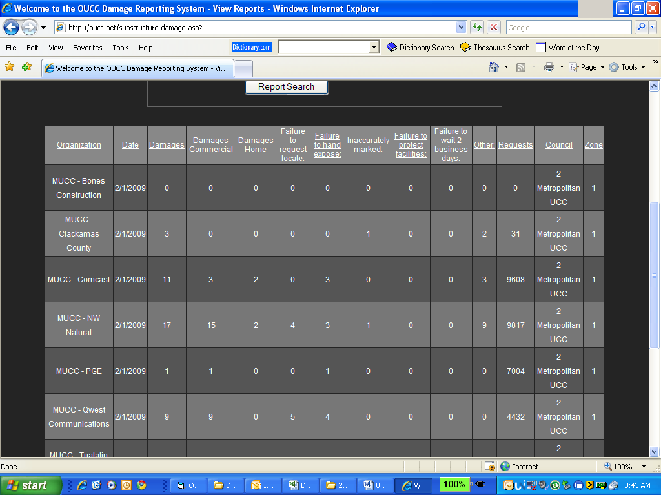
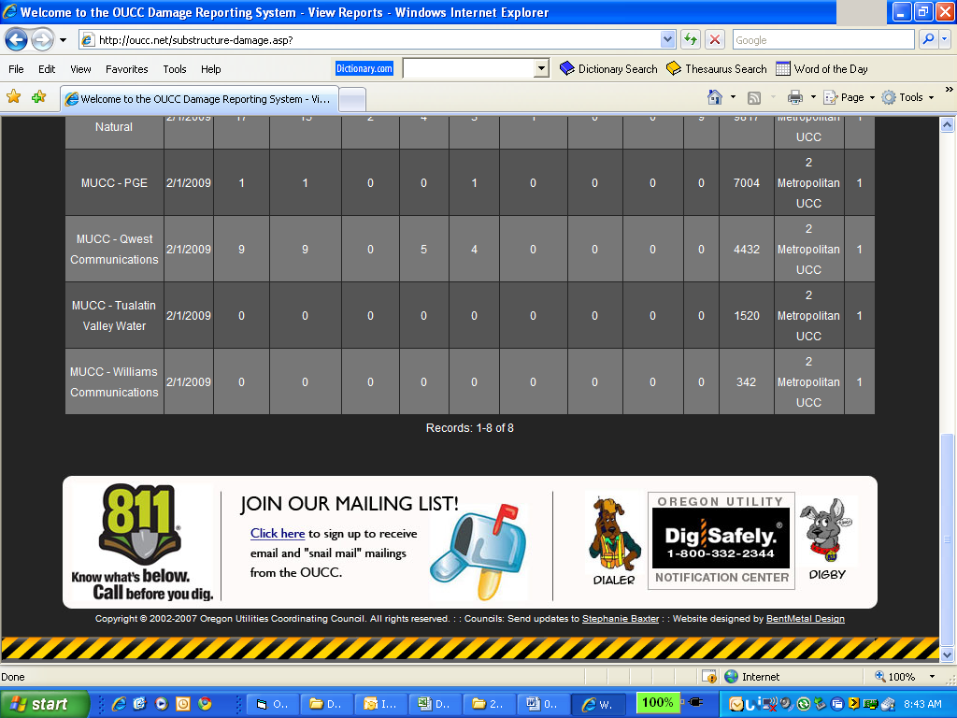

March 2009: NINE SUBMITTALS FOR DAMAGES
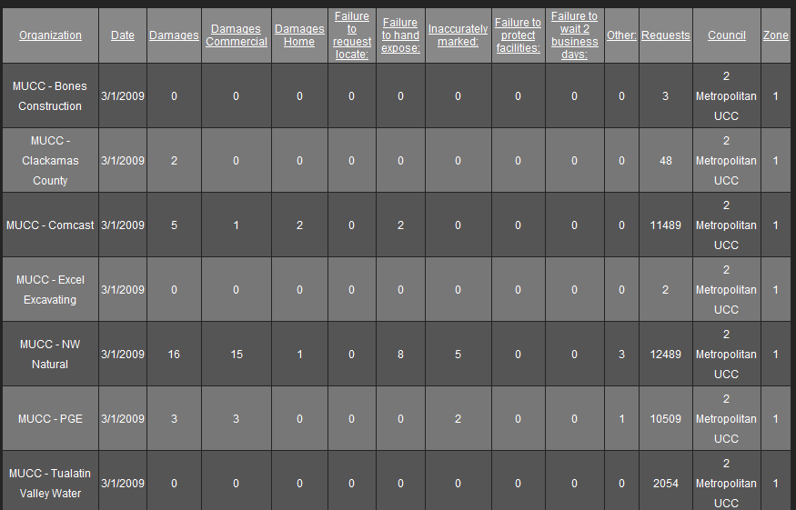
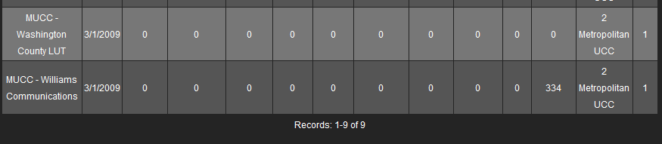

April 2009: FIVE SUBMITTALS FOR DAMAGES 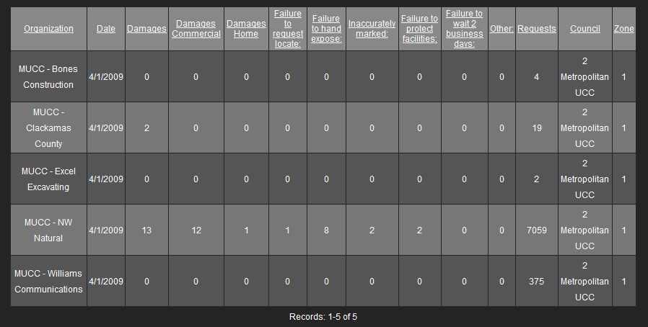

May 2009: ONLY TWO SUBMITTAL FOR DAMAGES SO FAR – GET YOUR REPORTS IN!
