Meeting Minutes

Metropolitan Utility Coordinating Council
MUCC, PO Box 12001, Portland, OR 97212-0001

June 24th, 2009
Our next meeting will be July 22nd, 2009

ATTENDEES: See attached listing.
__________________________________________________________________________________________________________________

REPORTS:

Treasurer’s Report for June 2008: No report this month – Jarrod was unavailable. Last month:

M Bank Golf Fund Golf Fund Rodeo Visa
(Checking) (Savings)
Beginning Balance $ 7,425.30 $ 734.61 $ 5.00 $ 0.00 $ -
Ending Balance $ 8,450.30 $ 734.61 $ 5.00 $ 0.00 $ -

Payments / Purchases:
We are still receiving dues paid from various members. We had a deposit of $1,025. Thank you all! If you haven’t submitted your dues, please do so (see the list at the end of the Minutes). We are a non-profit organization so all monies collected go toward supplies and events to educate the public!
We must bring down our ending balance to under $5,000 or we will have to pay taxes at the end of the year. There are several opportunities coming up where we can get some good exposure to the public. (See the P & E report.)
_____________________________________________________________________________________________________________________

Damage Report: (located at the end of these minutes)

Within the next year or two, these reports will be required nationwide. Start getting in the habit now to make it easier. It is a simple process. If you have questions, contact Shannon Davis, the Damage Chair. Her contact information is under the Executive Board within these minutes.

Make sure to report all your damages each month directly to the website http://oucc.net under Damages and then send a quick note to Shannon that you have reported. It is suggested that you report your damages within 30 days of the month you are reporting for with final figures. You can add original information but you cannot edit it on the website. If you have not signed up – it is real easy and only takes one minute! Contractors and Utility Owners as well as County’s and City’s should be reporting. MUCC still wants to see 5-7 reports each month though only three are required. The OUNC can track where issues are concentrated so they can educate in these area to reduce damages. Some states are already making it mandatory to report!
These reports let us know how the damages are occurring and at what percentages. Please report your damages by the 20th every month!

If your agency doesn’t care for the way your damages are reported, please contact Stephanie Baxter (website owner) at s2b@nwnatural.com.
Please go back and enter for your company if you haven’t already done so. We had nine for March, five for April, two for May, and so far, only for June. Monthly damage reports for the past four months can be found at the end of the minutes.
__________________________________________________________________________________________________________________

Standards Manual:

There is no update. They are looking at the Administrative Rules which should be done within the next two years.
The Standards Manual is completed and is available. It can be ordered from the OUNC website as can any and all P & E material. You can also go to www.digsafelyoregon.com for supplies. Contractors can contact Gary Hyatt for copies, (gfh@nwnatural.com, or at 503-226-4211 ext. 4320). If large quantities of manuals are requested it will need to be approved by an OUNC board member.
__________________________________________________________________________________________________________________

P&E Report (Publicity and Education):

P&E General:
Don Patterson has checked into the Chico Bag – a reusable bag in a pouch – as a handout. It can be printed with our logo and a minimum order of 500 bags costs $1,700. We should consider going in with other UCC’s on an order like this. This bag is manufactured out of Chico California.
We have T-shirts available ($15 each) like those seen at WASCO. They have an “I am Safety” slogan in bright colors. The logo is on the front; and the slogan “I am Safety” with Dialer and Digby is on the back. These are great for parades – we have 25 of each color.
We are looking at different products for the smaller public events (those that last only a few hours).
The Chitaqua Parade is the first weekend of August. We could have a booth there – Christine will check on the price for the booth. We can set up the banner, have our shirts, and set the booth up with a wheel, planes and other handouts for the public.
Don will check on smaller banners that will fit inside the booth, about 2’ x 3’ in size that will be great at all events and for smaller gatherings.
Pizza parties for contractors – to discuss their concerns. We should start with our Member List and expand from there. WE NEED VOLUNTEERS!!! We will start with Bones and XL Excavating to discuss the laws, and give out hats/t-shirts and other items.
OUNC is checking into Search Browsers to see if certain code words will get people to the right sites when they are looking up info on Call Before You Dig, One Call, Underground Locates, and such. The site 811.com does not direct people to our information. The correct website is www.call811.com .
Please send any ideas to help get the word out to Anita Floyd (anita.floyd@qwest.com).

811 CAMPAIGN:
Home Depot and the Common Ground Alliance (CGA) have signed the contract. The Orange Embrace Team will reach out to their employees – they will be trained to be knowledgeable in the Dig Laws. This will be done state wide. Anita can supply a list of which stores are in which UCC areas so each UCC can meet with their local stores for introductions and discussions. They will be sponsoring our campaign and their logo will be found on our newly redesigned flyers, stickers, and color code cards. The stores will have stickers on all digging equipment including shovels, post hole diggers and all machines will also have the 811 key chains. The Home Depot will be putting on Kids Workshops; their employees will have patches that mention “Ask me about Dig Safely” and will be giving hats out to the first 500 associates. The Orange Embrace Team will have Key chains, Color Code Cards, Hats and other information.
The magnets are being updated to look more like the color code cards.
There are new changes to the website – check them out.
You may go to www.call811.com website for more information. There are materials available to any company wanting them for FREE. Go to http://www.digsafelyoregon.com . Click on Media/Merchandise, then go to Merchandise. There are still t-shirts available; check the website as you can’t afford not to buy them!

CARD HOLDERS, CALENDARS AND COLOR CODE CARDS. 2009 Calendars are out of stock. Color Code Cards are still available from Pacific Marketing. Supplies can be ordered directly from the website at www.digsafelyoregon.com. Go to Media/Merchandise, then to Merchandise. Click on the “Company Store” link, and place your order.

REGIONAL LAW UPDATE: The next Update is in November for Coos County, Curry County, Douglas County. It is free, includes lunch, and will have lots of SWAG. The local councils will be asked to recommend contractors for the Golden Shovel Award for exceptional prevention of damages. Send your recommendations to Gary Hyatt (gfh@nwnatural.com). They will be relying heavily on the councils to volunteer. Sign up will be at www.digsafelyoregon.com closer to the time of the events.
As soon as the dates for 2009 are set, announcements will be made to recruit for help. Next year, there will be one in Portland/Pendleton.
_________________________________________________________________________________________________________________________

Upcoming Events:

HOME AND GARDEN SHOW; AND THE
YARD, GARDEN AND PATIO SHOW:

We need to discuss participation in one or both of these shows.
Next shows: HGS – October 1-4, 2009 at the Expo; YGP – February 12-14, 2010 at the Convention Center
(Thursday – Sunday) (Friday – Sunday)

The OUNC has new thick standing pads to help prevent leg/foot fatigue while at the booth. They are very cushy and have the 811 logo on them.

GOLF TOURNAMENT: We are having another golf tournament this year on July 24th, with a shotgun start at 7:30 at Stone Creek Golf Club in Oregon City. The price is $45/person (last year it was $70) with a maximum of 96 players allowed. The application/flyer and request for sponsors will be sent out. There will be lots of great prizes. Please contact Gary Hyatt if you want to be on the Golf Tournament Committee, if you can volunteer, or if you would like to be a Sponsor. This year, we are not donating to a charity. We will be putting the money into the local contractors to keep them up to date on the laws.

OLD BUSINESS:

RAA hearing: There were four cases by NWNG. Two for failure to call; one for failure to pothole; one was a second offense. Approximately 30 contractors a month are getting educated, and approximately 21-35 training sessions occur monthly.
Any contractor can call any Board Member to arrange for education for other contractors if they don’t want to file an RAA. This could be the first step to get everyone into compliance with the laws.
If you have any issues with a Contractor or a Utility Owner, file an RAA. The form can be found on the website under RAA process. Everyone should try to attend one of the RAA hearings to see what they are all about, and how the process works. The OUNC encourages attendance at the RAA hearings to see what the process is. It is very educational.

In lieu of calling 911, the Non-Emergency Response phone numbers by County are:

Clackamas County Multnomah County Washington County
(503) 655-8211 (503) 823-3333 503) 629-0111

Call Before You Dig T-shirts: STILL AVAILABLE – See the flyer attached! Go to the website www.digsafelyoregon.com/orderform-t-shirts.asp for complete information and ordering of the T-shirts. If you encounter difficulty uploading your logo, call Anita Floyd at 503-242-8920.

Don Patterson will put together a list of links to the Counties, Cities and the State websites. These will be available here in the minutes, and on our Website.
_____________________________________________________________________________________________________________________

Verizon is selling out in 14 states including Oregon and Washington. All land and fiber is going to Frontier Communications January 1st, 2010. They will be the 3rd largest in the Country.

NEW BUSINESS:

Some of the UCC’s are moving their meeting locations for convenience to their members for better attendance. Perhaps once a quarter we could change our location. When we change the location, we could each take ten (10) member names/numbers and call them two days prior to the meeting to let them know of the change of location for the meeting. Let’s find out what the contractors would like to hear at the meeting.
MUCC is considering moving either the August or September meeting to an alternate location to help bring in more attendance. Bring your location suggestions to the next meeting.
We should have monthly discussions of ongoing and upcoming projects.
We need to start an Agenda list for everyone to contribute to. If you have something that you want on the Agenda, please e-mail it to dhaase@co.clackamas.or.us by the Monday before the Meeting.
Jayson Hunt has been calling other contractors to get discussion items and build up attendance.
_____________________________________________________________________________________________________________________

Schools and Colleges: We need to check with the schools and colleges about their private lines that cross public Rights-of-Way. If you have/get any info from/for any of the schools or colleges, please pass it on to Gary Hyatt (gfh@nwnatural.com) or to Dawn Haase (dhaase@co.clackamas.or.us).
1) Building to Building across a right-of-way
2) From a pole in the right-of-way to a building
We need to discuss with them the installation of permanent locates if they have utilities in the right-of-way and we need to make sure they are a member of the One Call Center.
_____________________________________________________________________________________

Remember – CCC – Communicate, Coordinate, Cooperate!
_____________________________________________________________________________________________________________________

Locate Rodeo: The budget has been cut for this years Locate Rodeo. MUCC has voted to be a Gold Sponsor ($1,000) for the Rodeo. The Rodeo will be held at the Linfield College in McMinneville again this year. They will have the Seminar on Friday June 12th and the Rodeo on Saturday June 13th. Attendees for the Seminar only will pay a fee of $10. There will be a BBQ lunch/Awards ceremony following the Rodeo Saturday afternoon.
_____________________________________________________________________________________________________________________

Construction Projects:
XL Excavation – They may have a new job in downtown Hillsboro; and are working in Gresham (4th Street)
Bones Construction – Are working on 209th in Hillsboro; and are picking up at Tuefel Nursery.
Washington Co – has a list that they will e-mail
NWNG – they are following some grading projects; nothing major.
Clackamas County – Barton Bridge is closed for a month; Monterey will be closed July 13–Aug 1
ODOT – Oregon City Bridge is undergoing utility relocation; no new projects.
ODA – Will e-mail a list of the stimulus packages.
City of Sherwood – They have a waterline project going on.
City of Milwaukie – They are doing Sanitary on Johnson Creek Blvd (next phase).
Portland Water – Will send a list.
_____________________________________________________________________________________________________________________

Questions:
Q: What happens when the size of a locate job is large or there is a number of locate jobs for a company?
A: Once determined, the locator calls the contractor to have a pre-con to discuss timelines.
Q: Who owns the communication conduit in 99E? The company (Level 3) went Bankrupt.
A: Gary will check with the Once Call Board to see what the answer is. They meet in two weeks.
_____________________________________________________________________________________

What should we do to get the word out? This is an open request/outreach to get the word to the contractors. Should we do another Contractors Dinner? Or a Contractors Breakfast? Maybe a Contractors BBQ on a Friday afternoon? Or a tailgate Pizza gathering with the contractors? Give us your ideas and suggestions…Let’s get the word out! We will need to create a schedule and we will need volunteers. Please help out when/where you can.
We are considering three locations for these Contractor Appreciation/Training gatherings. Clackamas County, Washington County and Multnomah County. We need to check with the contractors to see who their Safety Coordinator is and when they hold their Safety Meetings for a breakfast training to fit into their schedule. We will need to fit their schedule, so will need some flexible people to help out.
Send any ideas to Don Patterson!
_____________________________________________________________________________________________________________________

It was suggested that we show by example what the color codes mean. In an area where locates have been called in and marked, we could have a person there (possibly in a Dialer or Digby outfit) with a sign showing what the different colors stand for. This could be very educational to the general public who do not attend our events or the Shows we have booths at.
_____________________________________________________________________________________________________________________

Another suggestion was to take our booth to School Fairs to get the interest of the children. We have color books, monoplanes, rulers, pens and pencils available. We could also have a “Spin the Wheel” for the kids to win prizes.
_____________________________________________________________________________________________________________________

It was mentioned to do this also for the Trade Apprenticeships, and the committee learned that this is something that OUNC already does, but we could be doing a better outreach.

Food to digest: As you can read there are a variety of opportunities for all to volunteer and help spread the word of our Call before You Dig message. These are great opportunities to network and get to know each other better too. Take advantage of these opportunities and make new friends. If you are able, make yourself available to be on a committee or to volunteer on any of the upcoming project(s) and events these next couple of years. This is what this Council is all about and how we strive to be excellent!
___________________________________________________________________________________________

OUNC OUCC
Oregon Utility Notification Center Oregon Utility Coordinating Council
www.digsafelyoregon.com www.oucc.net

Check out these websites for information on the Oregon Dig Law, upcoming events and information on your local Council(s).

Also available: information on best practices at www.commongroundalliance.com.
____________________________________________________________________________________________

Respectfully submitted by Dawn Haase.
____________________________________________________________________________________________________________________

The next meeting: Location: Village Inn at 1621 N.E 10th Ave in Portland
Date: Wednesday, July 22nd at 7:30am

The 2009 schedule is the 4th Wednesday of each month except November (the week before Thanksgiving) and December (no meeting).

January 28th February 25th March 25th April 22nd
May 27th June 24th July 22nd August 26th
September 23rd October 28th November 18th Dec - No meeting

2009 MUCC PAID MEMBERS
As of 07-15-09

Applied Professional Dirt & Aggregate Interchange, Inc. ODOT
Bones Construction, Inc. Ditch Witch Northwest Oldcastle Precast
City of Fairview Emery & Sons PacifiCorp / Pacific Power
City of Gladstone Excel Excavation Inc Port of Portland
City of Gresham, OPS Center Henkels & McCoy Portland General Electric
City of Happy Valley Knife River Qwest Communications
City of Hillsboro Linescape Robinson Bros Const Inc
City of Lake Oswego Locating, Inc. Sunrise Water Authority
City of Milwaukie Loy Clark Pipeline Tri-State Construction
City of Oregon City Multnomah County Tualatin Valley Water District
City of Tualatin North Sky Communications Verizon
Civil Works NW Inc Northwest Earthmovers, Inc. Washington County LUT
Clackamas County Williams Pipeline
Comcast

========================================================================================
2009 MUCC Executive Board
MUCC, PO Box 12001, Portland, OR 97212-0001

PRESIDENT:  Gary Hyatt  NW Natural  220 NW 2nd Ave, 3rd Floor  Portland OR 97209  Office - (503) 226-4211 ext 4320  gfh@nwnatural.com | VICE PRESIDENT / TREASURER:  Jarrod Morrison  Portland General Electric  3700 SE 17th Ave  Portland, OR 97202  Office - 503-736-5505  Cell - 503-849-7043  Fax - 503-736-5500  Jarrod.Morrison@pgn.com
SECRETARY:  Dawn Haase  Clackamas County DTD Eng  150 Beavercreek Rd  Oregon City OR 97045  Office – (503) 742-4682  Cell – (503) 789-5728  Fax – (503) 742-4659  dhaase@co.clackamas.or.us | PUBLICITY & EDUCATION:  Don Patterson  NW Natural  220 NW 2nd Ave, 3rd Floor  Portland OR 97209  Office - (503) 226-4211 ext 4387  Cell – 503-806-0845  Fax – (503) 273-4822  dwp@nwnatural.com

DAMAGE CHAIR:

Shannon Davis

Qwest

100 NW Kearney Ave
Bend, OR 97701

Office - 541-388-5296

Fax - 541 388-5269
Shannon.Davis@qwest.com
Damage Report
In 2009 we must have a minimum of three (3) damage reports per month. Submit your damages within 30 days.
From the Website http://oucc.net/ As of 07-1506-22-09:

March 2009: NINE SUBMITTALS FOR DAMAGES
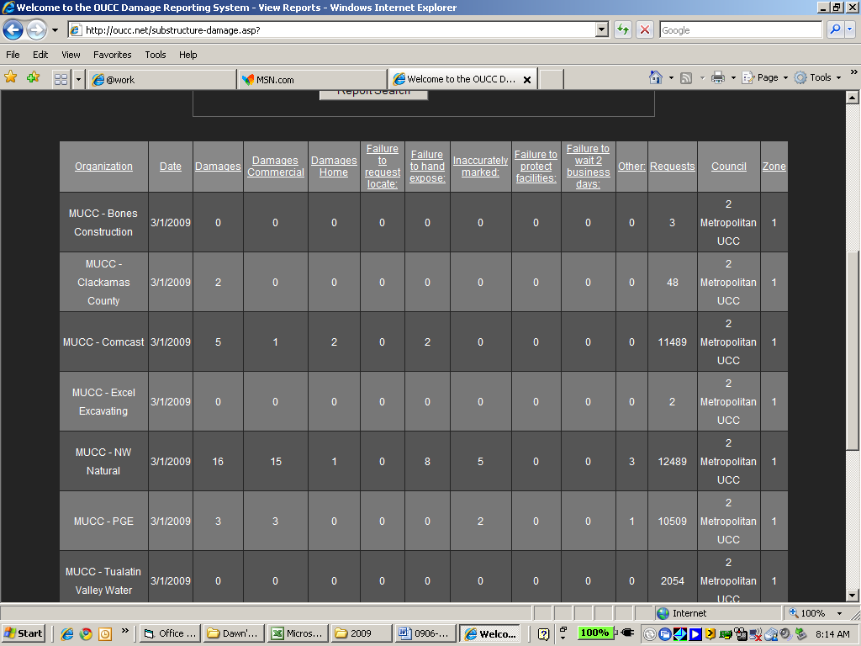
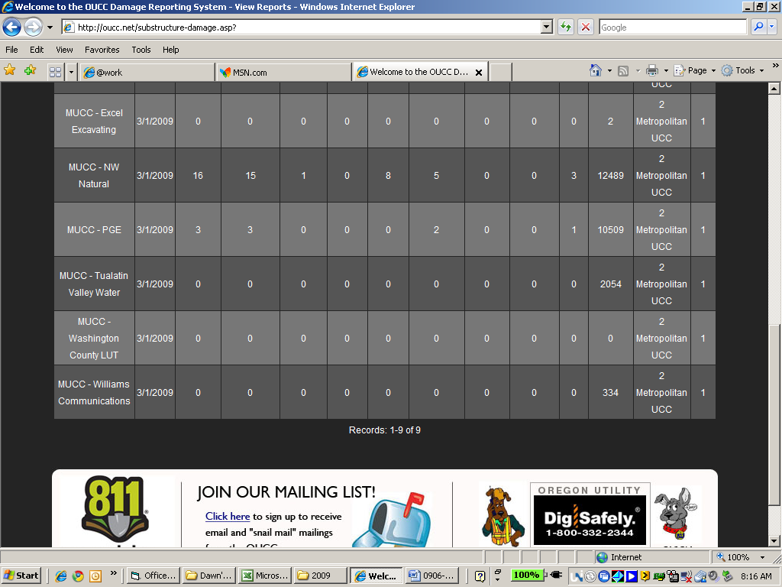

April 2009: SEVEN SUBMITTALS FOR DAMAGES
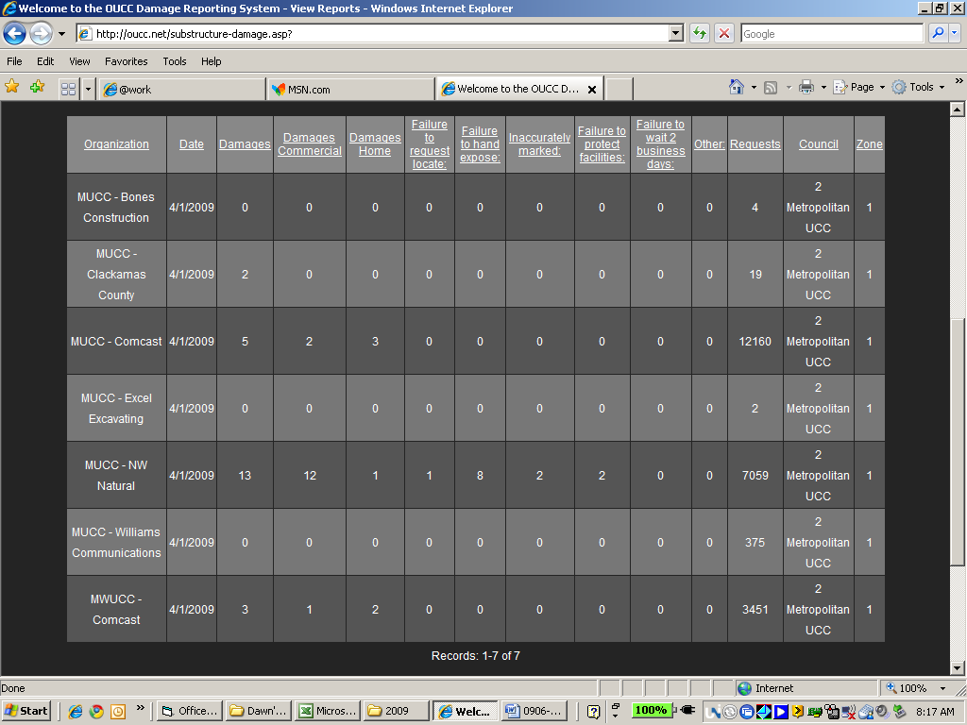

May 2009: NINE SUBMITTALS FOR DAMAGES
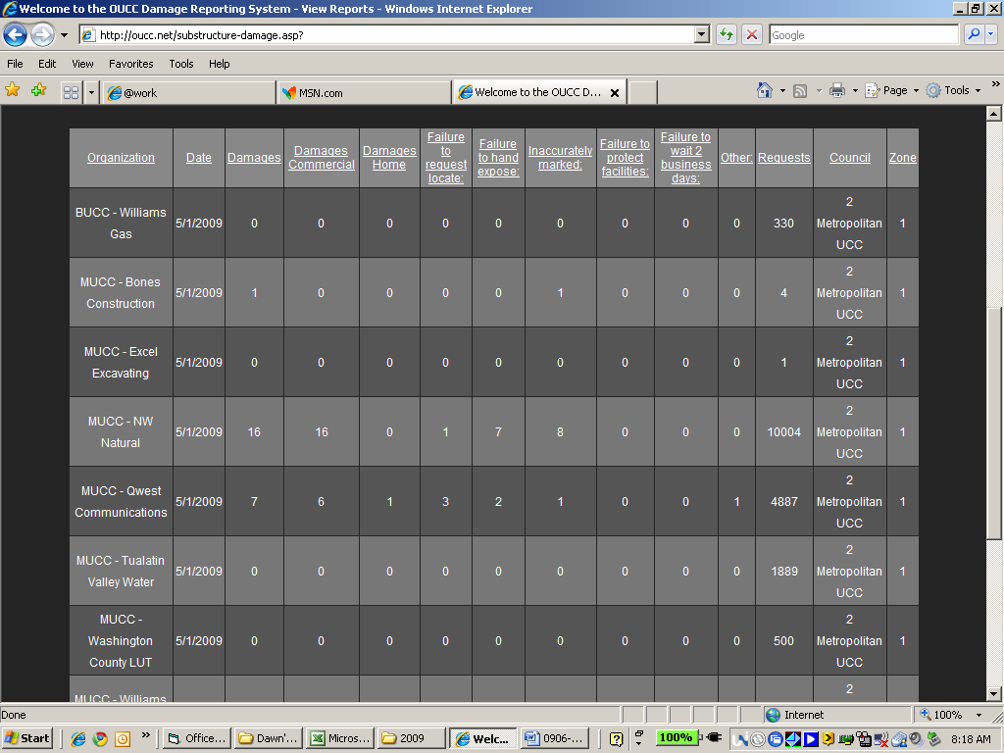
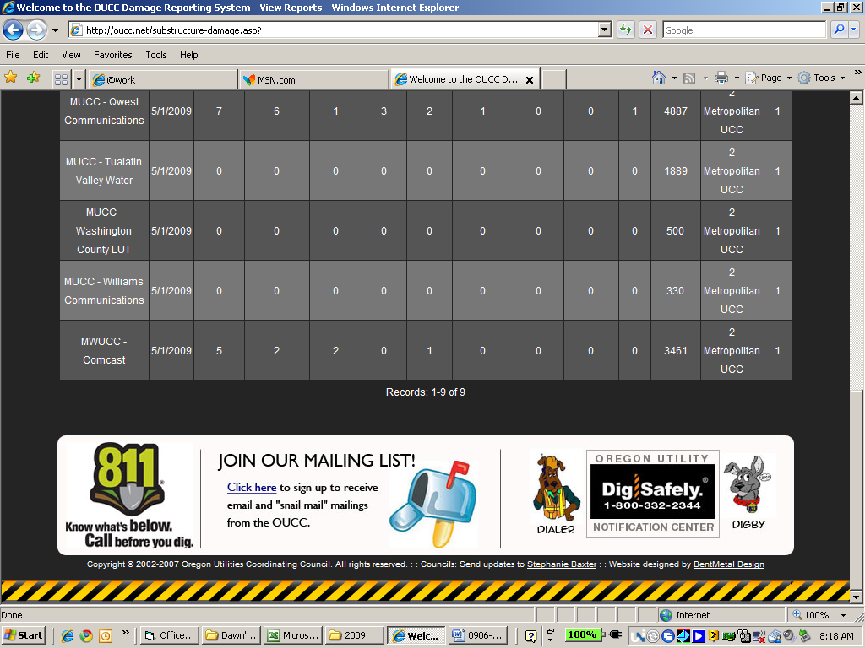

June 2009: ONLY TWO SUBMITTAL FOR DAMAGES SO FAR – GET YOUR REPORTS IN!
