Meeting Minutes

Metropolitan Utility Coordinating Council
MUCC, PO Box 12001, Portland, OR 97212-0001

April 22, 2009
Our next meeting will be May 27, 2009

ATTENDEES: See attached listing.
______________________________________________________________________________

REPORTS:

Treasurer’s Report for June 2008:

M Bank Golf Fund Golf Fund Rodeo Visa
(Checking) (Savings)
Beginning Balance $ 4,400.30 $ 734.61 $ 5.00 $ 0.00 $ -
Ending Balance $ 7,425.30 $ 734.61 $ 5.00 $ 0.00 $ -

Payments / Purchases:
We are receiving dues paid from various members. Thank you all! If you haven’t submitted your dues, please do so. We are a non-profit organization so all monies collected go toward supplies and events to educate the public!
________________________________________________________________________________

Damage Report: (located at the end of these minutes)

Make sure to report all your damages each month directly to the website http://oucc.net under Damages. It is suggested that you report your damages within 30 days of the month you are reporting for with final figures. You can add original information but you cannot edit it on the website. If you have not signed up – it is real easy and only takes one minute! Contractors and Utility Owners as well as County’s and City’s should be reporting. MUCC still wants to see 5-7 reports each month though only three are required. The OUNC can track where issues are concentrated so they can educate in these area to reduce damages. And remember, the more reports we submit now, the less the chance of having a mandatory reporting to the Federal Government. Some states are already making it mandatory to report!
These reports let us know how the damages are occurring and at what percentages. Please report your damages by the 20th every month!

If your agency doesn’t care for the way your damages are reported, please contact Stephanie Baxter (website owner) at s2b@nwnatural.com.
Please go back and enter for your company if you haven’t already done so. We had six for December, six for January, five for February and so far, five for March. Monthly damage reports for the past four months can be found at the end of the minutes.
____________________________________________________________________________

Standards Manual:

The Standards Manual is completed and is available. It can be ordered from the OUNC website as can any and all P & E material. You can also go to www.digsafelyoregon.com for supplies. Contractors can contact Gary Hyatt for copies, (gfh@nwnatural.com, or at 503-226-4211 ext. 4320). If large quantities of manuals are requested it will need to be approved by an OUNC board member.
____________________________________________________________________________

P&E Report (Publicity and Education):

Our P&E Chairperson (Don Patterson) would like to upgrade and update our booth. Things he is considering are to get poker chips (in the color codes) for a drawing at the booth to win prizes. He would like to find some larger items that will draw people in to learn about One Call as they try for prizes. He is also working with other UCC Boards to promote our message. He is going to see if the Clark County UCC would like to share a booth with us to help promote the phone numbers for Washington as well as Oregon. Clark County will give supplies, but volunteers are hard to get.
Anita Floyd gave us an update on the P&E Report as Don Patterson was not at todays meeting. The 811 campaign is getting a contract together with Home Depot - all stores nationwide. They will be sponsoring our campaign and their logo will be found on our newly redesigned flyers, stickers, and color code cards. Most of the supplies with their logos may only be found in the Home Depot stores (after the contract has been signed). The Home Depot will be putting on Kids Workshops, their employees will have patches that mention “Ask me about Dig Safely” and will be giving hats out to the first 500 associates.
Oregon is setting the bar for the rest of the nation’s One Call Centers in getting the word out.
We want to get information to the OAN – Oregon Association of Nurseries to pass on to customers to call before planting that tree or bush by giving them something that says “How do you plant me?” with instructions to call before digging. OUNC will be investigating this issue this year. At the Yard, Garden and Patio Show, we received business cards from Al’s and Portland Nursery. They are requesting our Color Code Cards for their stores.
OUNC is looking to put more (smaller) billboards around the state, and are hoping the local UCC’s will be helpful in this endeavor.
The Regional Law Update was April 9th, and was a huge success. Two weeks before the event, there were only 48 people signed up. A mass e-mailing was sent out and we ended up with over 200 people. A survey will be coming with about five questions to get feed back to see if the event was as expected and answered the questions that were in everyone’s minds. The next Update should be this fall in Pendleton. (Details to follow as they become available.)
OUNC is checking into Search Browsers to see if certain code words will get people to the right sites when they are looking up info on Call Before You Dig, One Call, Underground Locates, and such. The site 811.com does not direct people to our information. The correct website is www.call811.com .

If anyone has any ideas to help get the word out, please send them to Anita Floyd (anita.floyd@qwest.com).

811 CAMPAIGN: The magnets are being updated to look more like the color code cards.
There are new changes to the website – check them out.
OUNC has rented a billboard at Exit 260B in Salem on I-5. It is visible from the north and south on the east side of the highway. The price for the billboard is $66K/year. Check it out the next time you drive through Salem! OUNC is looking into billboards across the state and asking the larger utility companies to help sponsor these boards. Billboards will be discussed at the next OUNC meeting.
You may go to www.call811.com website for more information. There are materials available to any company wanting them for FREE. Contact Gary Hyatt with the number wanted, or go to http://www.digsafelyoregon.com/. There are still t-shirts available; check the website as you can’t afford not to buy them!
Home Depot is jumping on board with educating the public. They have gone up to their Executive VP asking questions and would like to roll this out nationally.

CARD HOLDERS, CALENDARS AND COLOR CODE CARDS. Calendars are now available from Pacific Marketing, and Gary Hyatt has the order form. We need to get these out to the rental shops around the area.

REGIONAL LAW UPDATE: The next Update will be on Thursday April 9th, 2009 in Milwaukie at the Milwaukie Elks Lodge from 8 am to 2 pm, registration at 8:30. There will be over 200 participants for a day long training seminar on Oregon Dig Law and Damage Prevention. They would like to see between 200 and 250 at this next Update. CEU’s are available for most of the attendees in a variety of utility works. They are available for plumbers, landscapers and should be available for water by the end of the month. One additional seminar will be planned for the Portland area in 2009. They are free, include lunch, and will have lots of SWAG, including a drawing for a gift card for $500 to Pacific Marketing.. The local councils will be asked to recommend contractors for the Golden Shovel Award for exceptional prevention of damages. Send your recommendations to Gary Hyatt (gfh@nwnatural.com). They will be relying heavily on the councils to volunteer. Sign up will be at www.digsafelyoregon.com closer to the time of the events. The last event had 268 participants in Albany. This is the first one in the Metro area and is limited to 300 attendees. Notice was sent to 10,000 contractors and utilities. The event included a continental breakfast and lunch will be provided as well.
As soon as the dates for 2009 are set, announcements will be made to recruit for help. The first one is April 9th, 2009.
At the January MUCC meeting, Gary had asked for nominations for the Golden Shovel Award. Two companies were nominated and both will be receiving the Golden Shovel Awards. They are Bones Construction and Excel Excavating.

GOSH CONFERENCE: The GOSH Conference is March 9-11 at the Convention Center. They need help to man the booth on Wednesday March 11. A sign up sheet was passed around at the meeting to fill in the gap of three hours in the morning.

YARD GARDEN AND PATIO SHOW. 2009 Yard, Garden & Patio Show (Feb 27 – March 1 2009) was a success. Many home owners stopped at the booth with stories of their own or their neighbors. Many already call for locates and many asked questions. We have interest from several big businesses; they left their cards at our booth. Anita Floyd is contacting them.
The OUNC has new thick standing pads to help prevent leg/foot fatigue while at the booth. They are very cushy and have the 811 logo on them.
Reminder: If you were a volunteer at the YGP, and have not had your parking reimbursed, bring your parking pass for reimbursement, or mail it to Jarrod Morrison (address at the end of the minutes under Executive Board Members).

Next shows: HGS – October 1-4, 2009 at the Expo; YGP – February 12-14, 2010 at the Convention Center
____________________________________________________________________________

OLD BUSINESS:

RAA hearing: There were several cases heard at the last hearing. There was one with Salem vs. the contractor and ended up with a $1000 fine and training required.
If you have any issues with a Contractor or a Utility Owner, file an RAA. The form can be found on the website under RAA process. Everyone should try to attend one of the RAA hearings to see what they are all about, and how the process works. The OUNC encourages attendance at the RAA hearings to see what the process is. It is very educational.

In lieu of calling 911, the Non-Emergency Response phone numbers by County are:

Clackamas County Multnomah County Washington County
(503) 655-8211 (503) 823-3333 503) 629-0111

Call Before You Dig T-shirts: STILL AVAILABLE – Contact Gary Hyatt or Anita Floyd

From Jamie: The Yamhill MWUCC is looking into sponsoring a Fishing Derby in 2009 (instead of a Golf Tourney). They will be contacting neighboring UCC’s (including us) to co-sponsor this event. It will take place at Vernonia Lake in Vernonia with tagged fish and a variety of categories to win a prize in. I’m sure volunteers will be needed for this fun event! More info to come…
____________________________________________________________________________

Gary has suggested a couple of ideas for the next year; more discussion will follow at the next meeting.

1st We should be submitting monthly reports on any ongoing projects.
2nd The MUCC should visit with contractors and give them on site education.
3rd Bring a pizza to a contractor for lunch to teach them and show them that we are here to educate them, we are not “out to get them”.

For large projects in any County or City, a pre-con with the Utility owners is required prior to beginning the project.
______________________________________________________________________________

Jurisdictions are gearing up to receive their Stimulus checks which need to be spent within six months. Be aware and prepared for a lot of work in the local areas.
______________________________________________________________________________

Don Patterson will put together a list of links to the Counties, Cities and the State websites. These will be available here in the minutes, and on our Website.
______________________________________________________________________________

Verizon is coming to an end of their project in the Portland area. They will do about the same distance this year as last year (1 million feet – or – about 125,000’ per month). Most of this is expected to be in Clackamas County, in the I-205/Sunnyside area out to Orient. They are also planning work in the Washougal area, and the Dayton / Lafayette area.

White lining – Pre-marking. When calling ITIC, five as detailed information as possible. Make sure the area lines up with the wording description on the locate ticket. It was suggested that the requestor put the date and their company name on the white lines for identification purposes.
_____________________________________________________________________________________________________________________

Emergency Locates – there are 400 – 1000 per month received. There are three types of tickets: 1. 48 hour notice. 2. Emergency (which is getting abused). And 3. Short Order (which has no guarantee of completion within the time needed). The calling entities need to learn to call them in per the laws. RAA complaints are being filed against several entities who are calling in false emergencies.
One is where the City is installing a new water line and putting service to the curb. The residents are on the old line, and the City is calling in emergency to switch service from the old line to the new line using the excuse that the customer is without service. Fifteen of these were called in – half will be filed as RAA complaints.
Over a period of two months, this contractor has called in a stack of located that is 2” deep that they are saying are emergencies.

NEW BUSINESS:
_____________________________________________________________________________________________________________________

GOLF: We are having another golf tournament this year, but do not have the date or committee set up yet. (This is a great opportunity to help on the committee and make new friends!) We hope to have it at Stone Creek again, and are trying to schedule it around the other tournaments that take place around that time. We are looking for Volunteers and Sponsors; meetings will begin soon. Please contact Gary Hyatt if you want to be on the Golf Tournament Committee.
_____________________________________________________________________________________________________________________

1st Choice Traffic Supply will have its Grand Opening on Saturday May 9, 2009. They will have all kinds of safety supplies and will be open to everyone – individuals and companies.
____________________________________________________________________________________

Locate Rodeo: The budget has been cut for this years Locate Rodeo. MUCC has voted to be a Gold Sponsor ($1,000) for the Rodeo. The Rodeo will be held at the Linfield College in McMinneville again this year. They will have the Seminar on Friday June 12th and the Rodeo on Saturday June 13th. Attendees for the Seminar only will pay a fee of $10. There will be a BBQ lunch/Awards ceremony following the Rodeo Saturday afternoon.
_____________________________________________________________________________________________________________________

If you have any changes to your project listings, please send them to Dawn Haase at dhaase@co.clackamas.or.us to add to the minutes. At the next meeting, we will discuss upcoming projects and scheduling.
_____________________________________________________________________________________

What should we do to get the word out? This is an open request/outreach to get the word to the contractors. Should we do another Contractors Dinner? Or a Contractors Breakfast? Maybe a Contractors BBQ on a Friday afternoon? Or a tailgate Pizza gathering with the contractors? Give us your ideas and suggestions…Let’s get the word out! We will need to create a schedule and we will need volunteers. Please help out when/where you can.
We are considering three locations for these Contractor Appreciation/Training gatherings. Clackamas County, Washington County and Multnomah County. We need to check with the contractors to see who their Safety Coordinator is and when they hold their Safety Meetings for a breakfast training to fit into their schedule. We will need to fit their schedule, so will need some flexible people to help out. NUCA Safety Committee meets the last week of April – our MUCC members will bring this up at that meeting. The NUCA dinner meeting will be in June at the Monarch Hotel. The last meeting had over 100 people.
Send any ideas to Don Patterson!
_____________________________________________________________________________________

Washington County had an Early Summer Safety program. Anita Floyd attended and gave out good information and cleared up some misunderstandings.
_____________________________________________________________________________________

It was suggested that we show by example what the color codes mean. In an area where locates have been called in and marked, we could have a person there (possibly in a Dialer or Digby outfit) with a sign showing what the different colors stand for. This could be very educational to the general public who do not attend our events or the Shows we have booths at.
_____________________________________________________________________________________

Another suggestion was to take our booth to School Fairs to get the interest of the children. We have color books, monoplanes, rulers, pens and pencils available. We could also have a “Spin the Wheel” for the kids to win prizes.
_____________________________________________________________________________________

It was mentioned to do this also for the Trade Apprenticeships, and the committee learned that this is something that OUNC already does, but we could be doing a better outreach.

Food to digest: As you can read there are a variety of opportunities for all to volunteer and help spread the word of our Call before You Dig message. These are great opportunities to network and get to know each other better too. Take advantage of these opportunities and make new friends. If you are able, make yourself available to be on a committee or to volunteer on any of the upcoming project(s) and events these next couple of years. This is what this Council is all about and how we strive to be excellent!
___________________________________________________________________________________________

OUNC OUCC
Oregon Utility Notification Center Oregon Utility Coordinating Council
www.digsafelyoregon.com www.oucc.net

Check out these websites for information on the Oregon Dig Law, upcoming events and information on your local Council(s).

Also available: information on best practices at www.commongroundalliance.com.
__________________________________________________________________

Respectfully submitted by Dawn Haase.

The next meeting:
Location: Village Inn at 1621 N.E 10th Ave in Portland
Date: Wednesday, May 27th at 7:30am

The 2009 schedule is the 4th Wednesday of each month except November (the week before Thanksgiving) and December (no meeting).

January 28th February 25th March 25th April 22nd
May 27th June 24th July 22nd August 26th
September 23rd October 28th November 18th Dec - No meeting

2009 MUCC PAID MEMBERS
As of 04-20-09
Bones Construction, Inc. | Multnomah County
City of Fairview | North Star
City of Gladstone | Northwest Earthmovers, Inc.
City of Gresham, OPS Center
City of Hillsboro | PacifiCorp / Pacific Power
City of Milwaukie | Port of Portland
City of Oregon City | Portland General Electric
City of Tualatin
Comcast | Qwest Communications
Dirt & Aggregate Interchange, Inc. | Robinson Bros Construction Inc.
Ditch Witch Northwest
 | Sunrise Water Authority
Emery & Sons
 | Tri-State Construction
Henkels & McCoy | Tualatin Valley Water District
Linescape | Oldcastle Precast
Locating, Inc.
Loy Clark Pipeline | Washington County LUT
 | Williams Pipeline

2009 MUCC Executive Board
MUCC, PO Box 12001, Portland, OR 97212-0001

PRESIDENT:  Gary Hyatt  NW Natural  220 NW 2nd Ave, 3rd Floor  Portland OR 97209  Office - (503) 226-4211 ext 4320  gfh@nwnatural.com | VICE PRESIDENT / TREASURER:  Jarrod Morrison  Portland General Electric  3700 SE 17th Ave  Portland, OR 97202  Office - 503-736-5505  Cell - 503-849-7043  Fax - 503-736-5500  Jarrod.Morrison@pgn.com
SECRETARY:  Dawn Haase  Clackamas County DTD Eng  150 Beavercreek Rd  Oregon City OR 97045  Office – (503) 742-4682  Cell – (503) 789-5728  Fax – (503) 742-4659  dhaase@co.clackamas.or.us | PUBLICITY & EDUCATION:  Don Patterson  NW Natural  220 NW 2nd Ave, 3rd Floor  Portland OR 97209  Office - (503) 226-4211 ext 4387  Cell – 503-806-0845  Fax – (503) 273-4822  dwp@nwnatural.com

DAMAGE CHAIR:

Shannon Davis

Qwest

100 NW Kearney Ave
Bend, OR 97701

Office - 541-388-5296

Fax - 541 388-5269
Shannon.Davis@qwest.com

Damage Report
In 2009 we must have a minimum of three (3) damage reports per month. Submit your damages within 30 days.

From the Website http://oucc.net/ As of 05-13-09:

January 2009: SEVEN SUBMITTALS FOR DAMAGES
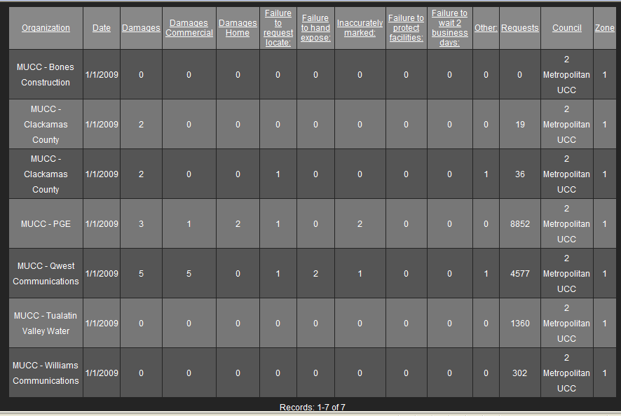

February 2009: EIGHT SUBMITTALS FOR DAMAGES
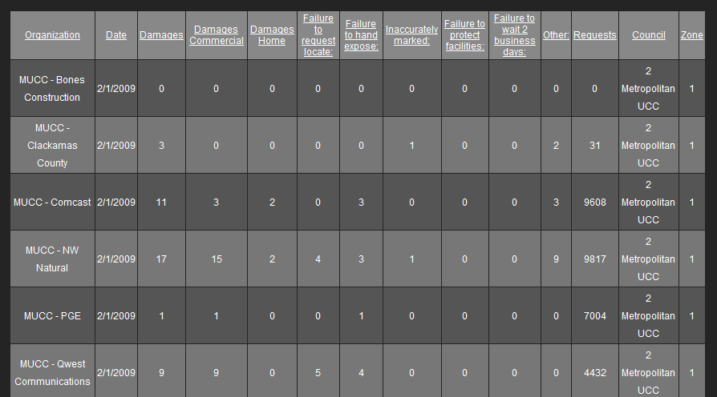
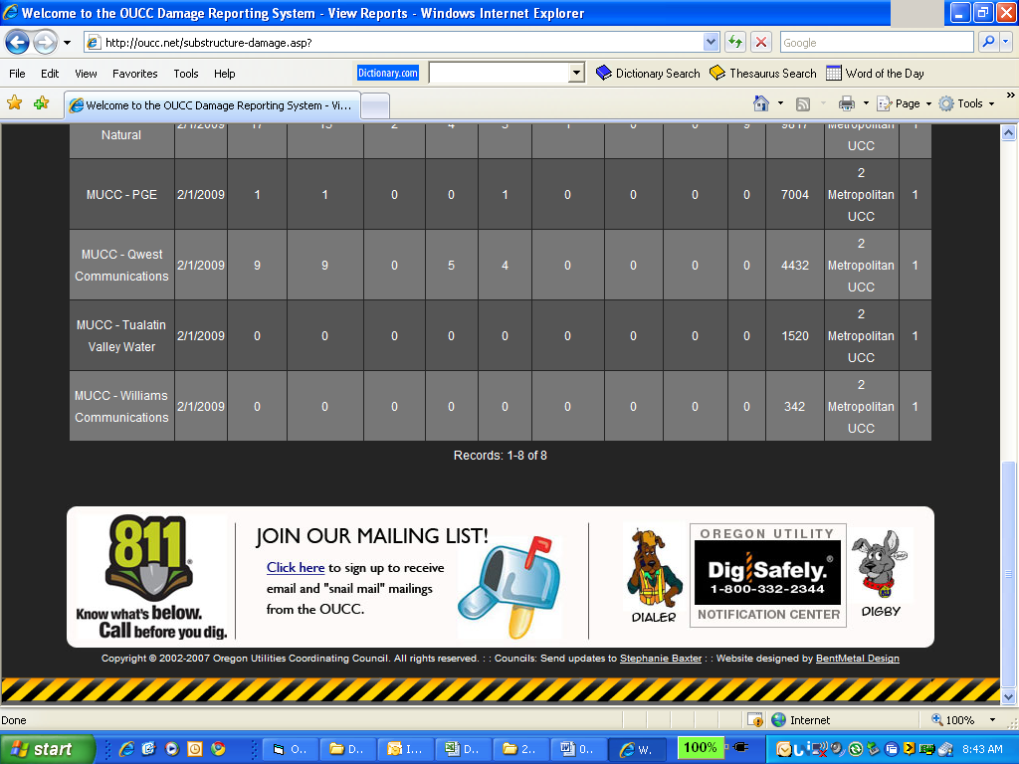

March 2009: EIGHT SUBMITTALS FOR DAMAGES
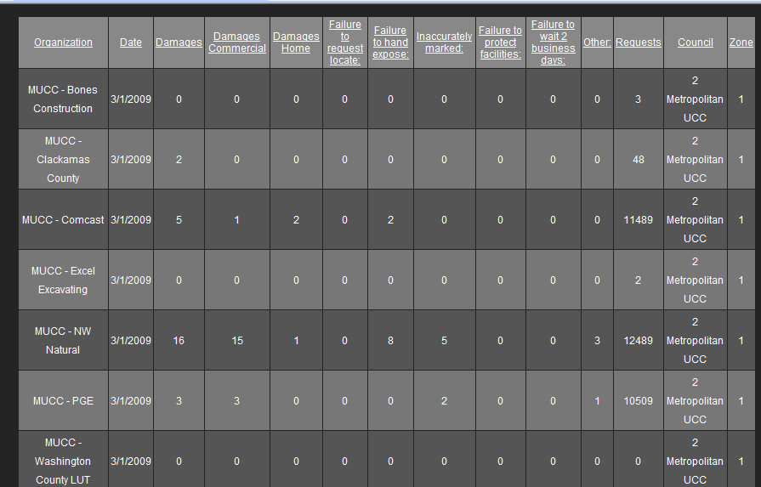
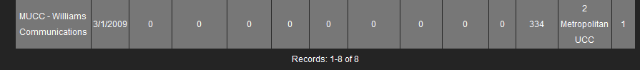

April 2009: ONLY TWO SUBMITTALS FOR DAMAGES SO FAR – GET YOUR REPORTS IN!
