Meeting Minutes

Metropolitan Utility Coordinating Council
MUCC, PO Box 12001, Portland, OR 97212-0001

February 25, 2009
Our next meeting will be March 25, 2009

ATTENDEES: See attached listing.
______________________________________________________________________________

REPORTS:

Treasurer’s Report for June 2008:

M Bank Golf Fund Golf Fund Rodeo Visa
(Checking) (Savings)
Beginning Balance $ 5,988.75 $ 2,168.85 $ 5.00 $ 0.00 $ -
Ending Balance $ 4,223.30 $ 2,484.61 $ 5.00 $ 0.00 $ -

Payments / Purchases:
There were various checks to OAN (Oregon Association of Nurseries) for our booth, table cover, and extra tickets for the Yard, Garden and Patio Show.
Dues remain the same - $75 for non-utilities and small water districts, and $125 for major utilities. Invoices were handed out at the February MUCC meeting and remaining were mailed.
We will be donating $1500 to the Ronald McDonald House from the proceeds of the golf tournament. This is $500 more than last year and $700 more than the year before! Jarrod has set up an appointment to tour the facility and deliver the check on Friday, March 6th at 10:00. Please contact Jarrod Morrison if you would like to tour the facilities when the check is presented.
________________________________________________________________________________

Damage Report: (located at the end of these minutes)

Make sure to report all your damages each month directly to the website http://oucc.net under Damages. It is suggested that you report your damages within 30 days of the month you are reporting for with final figures. You can add original information but you cannot edit it on the website. If you have not signed up – it is real easy and only takes one minute!
These reports let us know how the damages are occurring and at what percentages. Please report your damages by the 20th every month!

If your agency doesn’t care for the way your damages are reported, please contact Stephanie Baxter (website owner).

OUNC continues to sponsor a program to encourage participation for local Councils to submit monthly damage reports. OUNC is offering cash incentives monthly and quarterly to those Councils who report their damages to them. The incentive is up to $1,200. We need to submit our Officers List, which Gary will take care of, and we must have a minimum of five damage reports monthly in order to qualify for these incentives. We had seven for November, five for December, six for January, and so far, two for February. Please go back and enter for your company if you haven’t already done so. Another part of the incentive is to add one new member to our Council each year. Last year we added four new members. We will need one additional member this coming year to qualify for the $1,200. Gary Hyatt will check with United Pipe to become a member and will check with the local Engineering firms as well to attend or be members. Monthly damage reports for the past three months can be found at the end of the minutes.
____________________________________________________________________________

Standards Manual:

The Standards Manual is completed and is available. It can be ordered from the OUNC website as can any and all P & E material. You can also go to www.digsafelyoregon.com for supplies. Contractors can contact Gary Hyatt for copies, (gfh@nwnatural.com, or at 503-226-4211 ext. 4320). If large quantities of manuals are requested it will need to be approved by an OUNC board member.
____________________________________________________________________________

P&E Report (Publicity and Education):

CARD HOLDERS, CALENDARS AND COLOR CODE CARDS. Calendars are now available from Pacific Marketing, and Gary Hyatt has the order form. We need to get these out to the rental shops around the area.

YARD GARDEN AND PATIO SHOW. 2009 Yard, Garden & Patio Show (Feb 27 – March 1 2009) will be coming up soon. There is a sign up sheet that is almost full. Please check it out and see if you are available to fill any of the open shifts. Call Dawn Haase at 503-789-5728 if you can help out. OUNC will be paying half of the price for the booth to all UCC’s that want to participate in shows of this nature to get the word out. IF YOU WERE A VOLUNTEER AT THE YGP, BRING YOUR PARKING PASS FOR REIMBURSEMENT, OR MAIL IT TO JARROD MORRISON (ADDRESS AT THE END OF THE MINUTES UNDER EXECUTIVE BOARD MEMBERS)

811 CAMPAIGN: OUNC has rented a billboard at Exit 260B in Salem on I-5. It is visible from the north and south on the east side of the highway. The price for the billboard is $66K/year. Check it out the next time you drive through Salem! OUNC is looking into billboards across the state and asking the larger utility companies to help sponsor these boards.
You may go to www.call811.com website for more information. There are materials available to any company wanting them for FREE. Contact Gary Hyatt with the number wanted, or go to http://www.digsafelyoregon.com/. There are still t-shirts available; check the website as you can’t afford not to buy them!

REGIONAL LAW UPDATE: The next Update will be on Thursday April 9th, 2009 in Milwaukie at the Milwaukie Elks Lodge from 8 am to 2 pm, registration at 8:30. There will be over 200 participants for a day long training seminar on Oregon Dig Law and Damage Prevention. They would like to see between 200 and 250 at this next Update. CEU’s are available for most of the attendees in a variety of utility works. One additional seminar will be planned for the Portland area in 2009. They are free, include lunch, and will have lots of SWAG, including a drawing for a gift card for $500 to Pacific Marketing.. The local councils will be asked to recommend contractors for the Golden Shovel Award for exceptional prevention of damages. Send your recommendations to Gary Hyatt (gfh@nwnatural.com). They will be relying heavily on the councils to volunteer. Sign up will be at www.digsafelyoregon.com closer to the time of the events. The last event had 268 participants in Albany. This is the first one in the Metro area and is limited to 300 attendees. Notice was sent to 10,000 contractors and utilities. The event included a continental breakfast and lunch will be provided as well.
As soon as the dates for 2009 are set, announcements will be made to recruit for help. The first one is April 9th, 2009.

GOSH CONFERENCE: The GOSH Conference is March 9-11 at the Convention Center. They need help to man the booth on Wednesday March 11. A sign up sheet was passed around at the meeting to fill in the gap of three hours in the morning.
____________________________________________________________________________

OLD BUSINESS:

RAA hearing: There were several cases heard at the last hearing. There was one with NWNG, one a contractor vs. Salem Electric and vice versa, Salem Electric vs. the contractor. These last two involved not maintaining marks and/or digging outside of the excavation area.
If you have any issues with a Contractor or a Utility Owner, file an RAA. The form can be found on the website under RAA process. Everyone should try to attend one of the RAA hearings to see what they are all about, and how the process works. The OUNC encourages attendance at the RAA hearings to see what the process is. It is very educational.

In lieu of calling 911, the Non-Emergency Response phone numbers by County are:

Clackamas County Multnomah County Washington County
(503) 655-8211 (503) 823-3333 503) 629-0111

Call Before You Dig T-shirts: STILL AVAILABLE – CONTACT GARY HYATT

Patty spoke of the Greater Portland Construction Partnership Group meeting with about 75 people attending. It consists of large and small contractors meeting quarterly to discuss issues. This meeting was on crane safety. The dues are $250/ year. The purpose is to educate and communicate for a greater cause to minimize accidents. Patty will get me contact information, and MUCC will look into speaking at and sponsoring their appetizer (?) for an upcoming meeting. Their next quarterly meeting is at the Convention center in either December or January.
____________________________________________________________________________

From Jamie: The Yamhill MWUCC is looking into sponsoring a Fishing Derby in 2009 (instead of a Golf Tourney). They will be contacting neighboring UCC’s (including us) to co-sponsor this event. It will take place at Vernonia Lake in Vernonia with tagged fish and a variety of categories to win a prize in. I’m sure volunteers will be needed for this fun event!
____________________________________________________________________________

Gary has suggested a couple of ideas for the next year; more discussion will follow at the next meeting.

1st we should be submitting monthly reports on any ongoing projects.
2nd The MUCC should have the Utility companies submit contractors’ names to us who could use a refresher course in the One Call Laws and we (MUCC) would treat them to an on-site lunch and lessons in safety and the laws. ______________________________________________________________________________

For large projects in any County or City, a pre-con with the Utility owners is required prior to beginning the project.
______________________________________________________________________________

Jurisdictions are gearing up to receive their Stimulus checks which need to be spent within six months. Be aware and prepared for a lot of work in the local areas.
______________________________________________________________________________

Don Patterson will put together a list of links to the Counties, Cities and the State websites. These will be available here in the minutes, and on our Website.
______________________________________________________________________________

Verizon is coming to an end of their project in the Portland area. They will do about the same distance this year as last year (100 million feet – or – about 125,000’ per month). Most of this is expected to be in Clackamas County, in the I-205/Sunnyside area out to Orient. They are also planning work in the Washougal area, and the Dayton / Lafayette area.

NEW BUSINESS:

Home Depot is jumping on board with educating the public. They have requested materials to hand out in all their stores.
______________________________________________________________________________

GOLF: We are having another golf tournament this year, but do not have the date or committee set up yet. (This is a great opportunity to help on the committee and make new friends!) We hope to have it at Stone Creek again, and are trying to schedule it around the other tournaments that take place around that time.
______________________________________________________________________________

White lining – Pre-marking. When calling ITIC, five as detailed information as possible. Make sure the area lines up with the wording description on the locate ticket. It was suggested that the requestor put the date and their company name on the white lines for identification purposes.
______________________________________________________________________________

Emergency Locates – there are 400 – 1000 per month received. There are three types of tickets: 1. 48 hour notice. 2. Emergency (which is getting abused). And 3. Short Order (which has no guarantee of completion within the time needed). The calling entities need to learn to call them in per the laws.
______________________________________________________________________________

Ticket numbers are up! The word is getting out and people are calling in for locates!

Food to digest: As you can read there are a variety of opportunities for all to volunteer and help spread the word of our Call before You Dig message. These are great opportunities to network and get to know each other better too. Take advantage of these opportunities and make new friends. If you are able, make yourself available to be on a committee or to volunteer on any of the upcoming project(s) and events these next couple of years. This is what this Council is all about and how we strive to be excellent!
__________________________________________________________________

OUNC OUCC
Oregon Utility Notification Center Oregon Utility Coordinating Council
www.digsafelyoregon.com www.oucc.net

Check out these websites for information on the Oregon Dig Law, upcoming events and information on your local Council(s).

Also available: information on best practices at www.commongroundalliance.com.
__________________________________________________________________

Respectfully submitted by Dawn Haase.

The next meeting:
Location: Village Inn at 1621 N.E 10th Ave in Portland
Date: Wednesday, March 25th at 7:30am

The 2009 schedule is the 4th Wednesday of each month except November (the week before Thanksgiving) and December (no meeting).

January 28th February 25th March 25th April 22nd
May 27th June 24th July 22nd August 26th
September 23rd October 28th November 18th Dec - No meeting

2009 MUCC Executive Board
MUCC (new) Mailing PO Box address is: PO Box 12001, Portland, OR 97212-0001

PRESIDENT:  Gary Hyatt  NW Natural  220 NW 2nd Ave, 3rd Floor  Portland OR 97209  Office - (503) 226-4211 ext 4320  gfh@nwnatural.com | VICE PRESIDENT / TREASURER:  Jarrod Morrison  Portland General Electric  3700 SE 17th Ave  Portland, OR 97202  Office - 503-736-5505  Cell - 503-849-7043  Fax - 503-736-5500  Jarrod.Morrison@pgn.com
SECRETARY:  Dawn Haase  Clackamas County DTD Eng  150 Beavercreek Rd  Oregon City OR 97045  Office – (503) 742-4682  Cell – (503) 789-5728  Fax – (503) 742-4659  dawnpik@co.clackamas.or.us | PUBLICITY & EDUCATION:  Don Patterson  NW Natural  220 NW 2nd Ave, 3rd Floor  Portland OR 97209  Office - (503) 226-4211 ext 4387  Cell – 503-806-0845  Fax – (503) 273-4822  dwp@nwnatural.com

DAMAGE CHAIR:

Shannon Davis

Qwest

100 NW Kearney Ave
Bend, OR 97701

Office - 541-388-5296

Fax - 541 388-5269
Shannon.Davis@qwest.com

2008 MUCC PAID MEMBERS
as of 11-19-08
1st Choice Traffic Control | Locating, Inc.
 | Loy Clark
Applied Professional Services
 | Moore Excavation, Inc
Bones Construction, Inc. | Multnomah County
City of Fairview | Northwest Earthmovers, Inc.
City of Forest Grove | North West Natural
City of Gladstone
City of Gresham, OPS Center | ODOT
City of Happy Valley | Old Castle Precast
City of Hillsboro
City of Lake Oswego | PacifiCorp / Pacific Power
City of Oregon City | Portland General Electric
City of Sandy | Portland General Electric
City of Tualatin
Civil Works NW, Inc. | Qwest
Clackamas County
Comcast | Sunrise Water Authority
Dirt & Aggregate Interchange, Inc. | Tri-State Construction
Ditch Witch | Tualatin Valley Water District
Emery & Sons | Verizon
Henkels & McCoy | Washington County LUT
 | Williams Pipeline
James Fowler

Damage Report
In 2009 we must have a minimum of five (5) damage reports per month. Submit your damages within 30 days.

From the Website http://oucc.net/ As of 03-23-09:

November 2008: SEVEN SUBMITTALS FOR DAMAGES
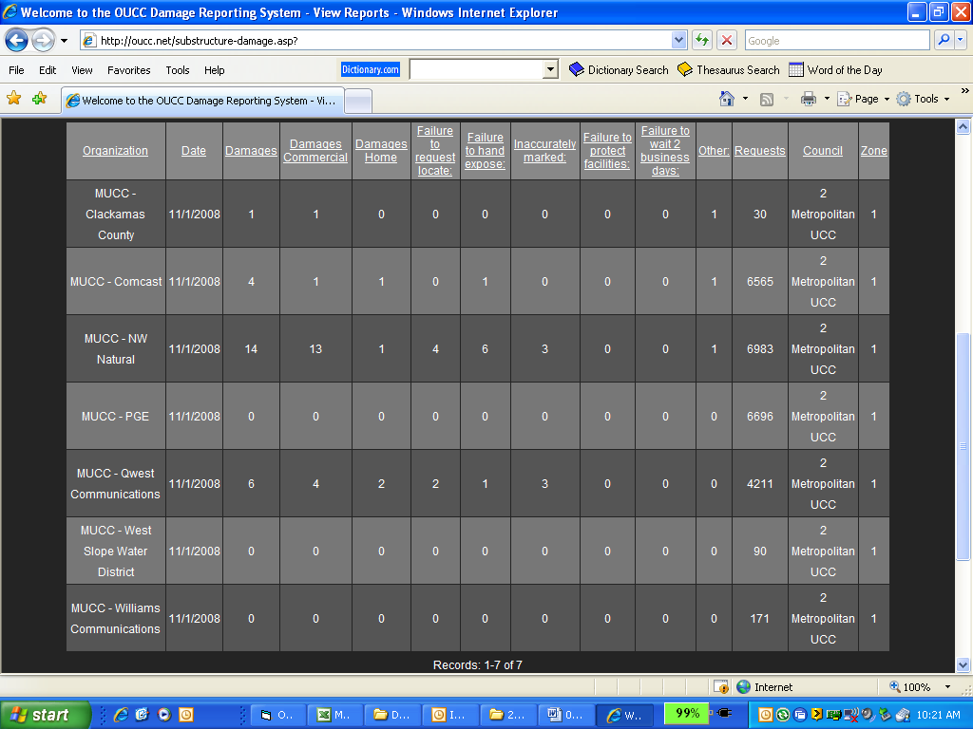

December 2008: FIVE SUBMITTALS FOR DAMAGES
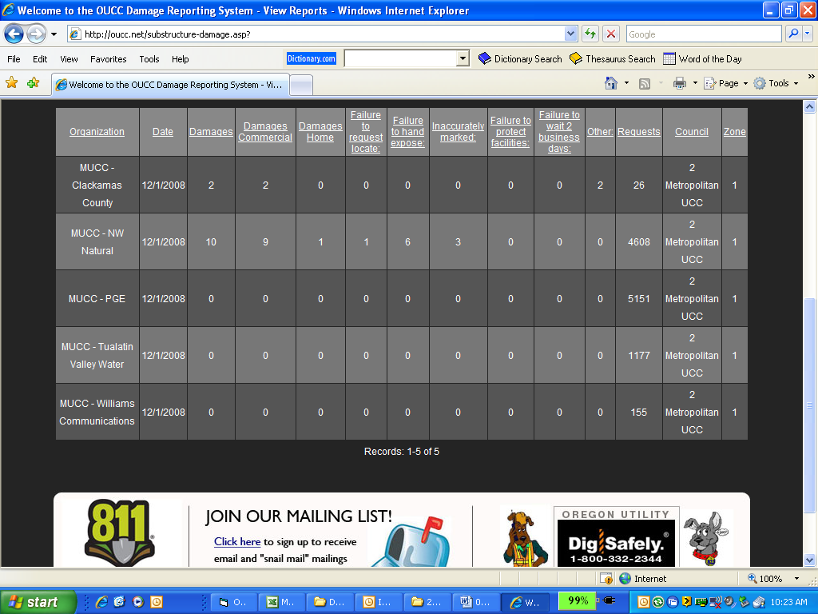

January 2009: SIX SUBMITTALS FOR DAMAGES – GREAT JOB!!!
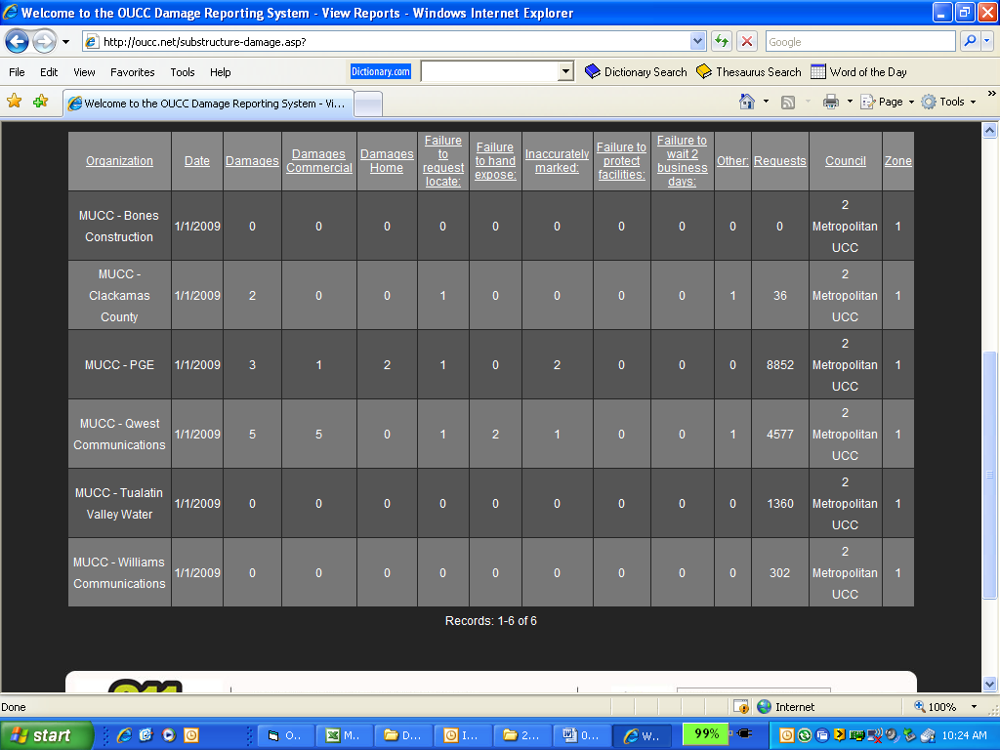

February 2009: SO FAR, TWO SUBMITTALS – GET YOUR DAMAGES REPORTED!!!
