Meeting Minutes

Metropolitan Utility Coordinating Council
MUCC, PO Box 12001, Portland, OR 97212-0001

September 23rd, 2009
Our next meeting will be October 28th, 2009
At the Village Inn in NE Portland

ATTENDEES: See attached listing.
__________________________________________________________________________________________________________________

REPORTS:

Treasurer’s Report for June 2008: No transactions so no changes this month.

M Bank Golf Fund Golf Fund Rodeo Visa
(Checking) (Savings)
Beginning Balance $ 4,171.77 $ 1,121.81 $ 5.00 $ 0.00 $ -
Ending Balance $ 4,171.77 $ 1,121.81 $ 5.00 $ 0.00 $ -

Payments / Purchases:
As a non-profit organization, all monies collected go for supplies/events to educate the public!
Our ending balance must be under $5,000 at the end of the year or we will have to pay (very high) taxes. There are opportunities coming up where we can get some good exposure to the public. See the P & E report.

Damage Report:

Over 4,000 realtors have been trained to call before installing their For Sale signs. Now we need to work on getting the Political Parties to call before installing all the campaign signs.
The Vac-Ex equipment users need to be re-educated on how to properly pothole for utilities. They can and have been damaging utilities by not starting their potholing at the outside edge of the utility zone, and by possible using too much water pressure.

These reports will soon be required nationwide. Get in the habit now to make it easier. If you have questions, contact Shannon Davis, at ShannonDavis@qwest.com. Some states are already making it mandatory to report!

Make sure to report all your damages each month directly to the website http://oucc.net under Damages and then send a quick note to Shannon that you have reported. It is suggested that you report your damages within 30 days of the month you are reporting for with final figures. You can add original information but you cannot edit it on the website. Signing up is real easy and only takes one minute! Contractors and Utility Owners as well as County’s and City’s should be reporting. MUCC wants to see 5-7 reports each month though only three are required. The OUNC can track where issues are concentrated so they can educate in these area to reduce damages.
These reports let us know how the damages are occurring and at what percentages. Please report your damages by the 20th every month!

If your agency doesn’t care for the way your damages are reported, please contact Stephanie Baxter (website owner) at s2b@nwnatural.com.
Please go back and enter for your company if you haven’t already done so. We had 12 for June, 12 for July, 6 for August and so far, 3 for September! Monthly damage reports for the past four months can be found at the end of the minutes.
__________________________________________________________________________________________________________________
Standards Manual:

They are looking at the Administrative Rules which should be done within the next two years.
The Standards Manual is completed and is available. It can be ordered from the OUNC website as can any and all P & E material. You can also go to www.digsafelyoregon.com for supplies. Contractors can contact Gary Hyatt for copies, (gfh@nwnatural.com, or at 503-226-4211 ext. 4320). If large quantities of manuals are requested it will need to be approved by an OUNC board member.
__________________________________________________________________________________________________________________

P&E Report (Publicity and Education):

P&E General:
WE NEED VOLUNTEERS!!! For a variety of educational opportunities coming up!
Steve Bacon P&R for Clark County will be getting together with us for joint ventures.
We can target some home owners at the golf clubs by sponsoring a tournament and setting up a booth for ½ a day, giving out our information and chances at free rounds of golf. Contact Don with any upcoming tournaments you know about.
Don has an idea for a game to be played at the Yard Garden and Patio show – it will be similar to “Who wants to be a Millionaire?” The public will answer questions to win prizes.
Don Patterson has checked into the Chico Bag – a reusable bag in a pouch – as a handout. It can be printed with our logo and a minimum order costs $1,700/ 500 bags. We should consider going in with other UCC’s on an order like this. This bag is manufactured out of Chico California.
We have T-shirts available ($15 each) like those seen at WASCO. They have an “I am Safety” slogan in bright colors. The logo is on the front; and the slogan “I am Safety” with Dialer and Digby is on the back. These are great for parades – we have 25 of each color.
We are looking at different products for the smaller public events (those that last only a few hours).
Don brought an example of a smaller banner that will fit inside the booth, about 2’ x 3’ in size that will be great at all events and for smaller gatherings. They run about $45 each. He is in the process of getting two banners for the MUCC events.
Pizza parties - Please call Gary Hyatt (503) 226-4211 ext 4320 if you can help. We can also invite other contractors to these pizza parties.
OUNC is checking into Search Browsers to see if certain code words will get people to the right sites when they are looking up info on Call Before You Dig, One Call, Underground Locates, and such. The site 811.com does not direct people to our information. The correct website is www.call811.com .
We need to find new venues such as local functions, Boy/Girl Scout gatherings, Farmers Markets, Soccer Parties…to get the word out! Don suggested finding out from the local Golf Courses when they would be having Tournaments, to see if we could be a sponsor and set up a booth – we could offer a raffle for a free round of golf to that course.
We need to promote the next step for safety after calling for locates.
Don will check into a local gardening show on Channel 12 to see if we can get some air time.
A curriculum is being developed to target children (4th graders). The Councils will need to take the lead to get the information across to the children.
Please send any ideas to help get the word out to Don Patterson (dwp@nwnatural.com) or to Anita Floyd (anita.floyd@qwest.com).

811 CAMPAIGN:
Home Depot will be online around April 2010 nationwide. They are already online through most of Oregon.
Anita can supply a list of which stores are in which UCC areas so each UCC can meet with their local stores for introductions and discussions. They will be sponsoring our campaign and their logo will be found on our newly redesigned flyers, stickers, and color code cards. The stores will have stickers on all digging equipment including shovels, post hole diggers and all machines will also have the 811 key chains. The Home Depot will be putting on Kids Workshops; the Orange Embrace Team will have Key chains, Color Code Cards, Hats and other information.
The magnets are being updated to look more like the color code cards. Both are available.
You may go to www.call811.com website for more information.
______________________________________________________________________________________

CARD HOLDERS, CALENDARS AND COLOR CODE CARDS AND OTHER MERCHANDISE. 2009 Calendars are out of stock. Color Code Cards are still available from Pacific Marketing. Supplies can be ordered directly from the website at www.digsafelyoregon.com. Go to Media/Merchandise, then to Merchandise. Click on the “Company Store” link, and place your order.

REGIONAL LAW UPDATE: Has been cancelled until spring of 2010 and will be held in Coos Bay or Pendleton. It is free, includes lunch, and will have lots of SWAG. The local councils will be asked to recommend contractors for the Golden Shovel Award for exceptional prevention of damages. Send your recommendations to Gary Hyatt (gfh@nwnatural.com). They will be relying heavily on the councils to volunteer. Sign up will be at www.digsafelyoregon.com closer to the time of the events.
As soon as the dates for 2009 are set, announcements will be made to recruit for help. Next year, there will be one in Portland/Pendleton.
_________________________________________________________________________________________________________________________

Upcoming Events:

THE 2010 YARD, GARDEN AND PATIO SHOW:

Next show: Friday through Sunday – February 12-14, 2010 at the Convention Center

Sign up now for your shift at the show by calling Dawn Haase at 503-789-5728 to let her know which shift you can take. (See the attached schedule for availability.) The OUNC has new thick standing pads to help prevent leg/foot fatigue while at the booth. They are very cushy and have the 811 logo on them.

Don Patterson will be updating the photos, and working on ideas for games/questions for bigger prizes to encourage interest in our booth.

2009 GOLF TOURNAMENT: The Tournament was July 24th, with a shotgun start at 7:30 at Stone Creek Golf Club in Oregon City. The price is $45/person with a maximum of 96 players allowed. There were lots of great prizes. This year, we will be putting the money into the local contractors to keep them up to date on the laws.
______________________________________________________________________________________________

OLD BUSINESS:

RAA Hearing:
Any contractor can call any Board Member to arrange for education for other contractors if they don’t want to file an RAA. This could be the first step to get everyone into compliance with the laws.
If you have any issues with a Contractor or a Utility Owner, file an RAA. The form can be found on the website under RAA process. Everyone should try to attend one of the RAA hearings to see what they are all about, and how the process works. The OUNC encourages attendance at the RAA hearings to see what the process is. It is very educational.

In lieu of calling 911, the Non-Emergency Response phone numbers by County are:

Clackamas County Multnomah County Washington County
(503) 655-8211 (503) 823-3333 503) 629-0111

Call Before You Dig T-shirts: STILL AVAILABLE! Go to www.digsafelyoregon.com/orderform-t-shirts.asp for complete information and ordering of T-shirts. If you encounter difficulty uploading your logo, call Anita Floyd at 503-242-8920.
_______________________________________________________________________________

Verizon is selling out in 14 states including Oregon and Washington. All land and fiber is going to Frontier Communications January 1st, 2010. They will be the 3rd largest in the Country. They are expected to be done in Clackamas County by October. They are currently in Happy Valley and the Damascus areas now.
______________________________________________________________________________________

NEW BUSINESS:

The remaining meetings for this year will continue to be held at the Village Inn in NE Portland. Between now and January’s meeting, we will be conducting a phone survey to see if other locations would work better to increase our attendance. Please let us know what would work best for your company. We will meet the needs of the majority and may end up moving our meetings around to accommodate everyone.
Perhaps once a quarter (or every other month) we could change our location. When we change the location, volunteers could each take ten (10) member names/numbers and call them two days prior to the meeting to let them know of the change of location for the meeting. Let’s find out what the contractors would like to hear at the meeting.
Several of our members will be calling all members who don’t currently attend to see if an alternate location would bring them to our meetings. Gary and Jarrod are putting together a list of questions.
Ralph Reisbeck/PGE has checked out some of the locations for a possible meeting spot and this is the best location he has found for the west side:
Denny’s @ Hwy 217 and SW Hall Blvd across from Washington Square did have area that could be blocked off & reserved for our group of 20-25 persons. There is no mandatory gratuity for the group, but 80% of the group must order a beverage such as coffee, tea, milk, juice or soda. So those that order breakfast with beverage and those that prefer to order just a beverage, we need a total of 80% of those attending. Denny’s is located at 8787 SW Scholl’s Ferry Road.

We should have monthly discussions of ongoing and upcoming projects. We will start an Agenda for everyone to contribute to. If you have something that you want on the Agenda, please e-mail it to dhaase@co.clackamas.or.us by the Tuesday before the Meeting.
______________________________________________________________________________________

Schools and Colleges: We need to check with the schools and colleges about their private lines that cross public Rights-of-Way. If you have/get any info from/for any of the schools or colleges, please pass it on to Gary Hyatt (gfh@nwnatural.com).
- Building to Building across a right-of-way
- From a pole in the right-of-way to a building
We need to discuss with them the installation of permanent locates if they have utilities in the right-of-way and we need to make sure they are a member of the One Call Center.
______________________________________________________________________________________

Remember – CCC – Communicate, Coordinate, Cooperate!

What should we do to get the word out? This is an open request/outreach to get the word to the contractors. Should we do another Contractors Dinner? Or a Contractors Breakfast? Maybe a Contractors BBQ on a Friday afternoon? Or a tailgate Pizza gathering with the contractors? Give us your ideas and suggestions…Let’s get the word out! We will need to create a schedule and we will need volunteers. Please help out when/where you can. We are considering three locations for these Contractor Appreciation/Training gatherings. Clackamas County, Washington County and Multnomah County. We need to check with the contractors to see who their Safety Coordinator is and when they hold their Safety Meetings for a breakfast training to fit into their schedules. We will need to fit their schedule, so will need some flexible people to help out. Send any ideas to Don Patterson!
______________________________________________________________________________________

VOLUNTEERS: As you have read, there are a variety of opportunities for all to volunteer and help spread the word of our Call before You Dig message. These are great opportunities to network and get to know each other better too. Take advantage of these opportunities and make new friends. If you are able, make yourself available to be on a committee or to volunteer on any of the upcoming projects and events these next couple of years. This is what this Council is all about and how we strive to be excellent!
______________________________________________________________________________________

OUNC OUCC
Oregon Utility Notification Center Oregon Utility Coordinating Council
www.digsafelyoregon.com www.oucc.net

Check out the websites for info on the Oregon Dig Law, upcoming events and on your local Council(s).
There are new changes to the website – check them out.
Also available: information on best practices at www.commongroundalliance.com
______________________________________________________________________________________

Respectfully submitted by Dawn Haase.
______________________________________________________________________________________

The next meeting: Location: Village Inn at 1621 N.E 10th Ave in Portland
Date: Wednesday, October 28th at 7:30am

The 2009 schedule is the 4th Wednesday of each month except November
(the week before Thanksgiving) and December (no meeting).

January 28th February 25th March 25th April 22nd
May 27th June 24th July 22nd August 26th
September 23rd October 28th November 18th Dec - No meeting
=====================================================================
The 2010 schedule is the 4th Wednesday of each month except November
(the week before Thanksgiving) and December (no meeting).

January 27th February 24th March 24th April 28th
May 26th June 23rd July 28th August 25th
September 22nd October 27th November 17th Dec - No meeting

2009 MUCC PAID MEMBERS
As of 07-15-09

Applied Professional  Bones Construction, Inc.  City of Fairview  City of Gladstone  City of Gresham, OPS Center  City of Happy Valley  City of Hillsboro  City of Lake Oswego  City of Milwaukie  City of Oregon City  City of Tualatin  Civil Works NW Inc  Clackamas County | Comcast  Dirt & Aggregate Interchange, Inc.  Ditch Witch Northwest  Emery & Sons  Excel Excavation Inc  Henkels & McCoy  Knife River  Linescape  Locating, Inc.  Loy Clark Pipeline  Multnomah County  North Sky Communications  Northwest Earthmovers, Inc. | Williams Pipeline  ODOT  Oldcastle Precast  PacifiCorp / Pacific Power  Port of Portland  Portland General Electric  Qwest Communications  Robinson Bros Const Inc  Sunrise Water Authority  Tri-State Construction  Tualatin Valley Water District  Verizon  Washington County LUT

========================================================================================
2009 MUCC Executive Board
MUCC, PO Box 12001, Portland, OR 97212-0001

PRESIDENT:  Gary Hyatt  NW Natural  220 NW 2nd Ave, 3rd Floor  Portland OR 97209  Office - (503) 226-4211 ext 4320  gfh@nwnatural.com | VICE PRESIDENT / TREASURER:  Jarrod Morrison  Portland General Electric  3700 SE 17th Ave  Portland, OR 97202  Office - 503-736-5505  Cell - 503-849-7043  Fax - 503-736-5500  Jarrod.Morrison@pgn.com
SECRETARY:  Dawn Haase  Clackamas County DTD Eng  150 Beavercreek Rd  Oregon City OR 97045  Office – (503) 742-4682  Cell – (503) 789-5728  Fax – (503) 742-4659  dhaase@co.clackamas.or.us | PUBLICITY & EDUCATION:  Don Patterson  NW Natural  220 NW 2nd Ave, 3rd Floor  Portland OR 97209  Office - (503) 226-4211 ext 4387  Cell – 503-806-0845  Fax – (503) 273-4822  dwp@nwnatural.com

DAMAGE CHAIR:

Shannon Davis

Qwest

100 NW Kearney Ave
Bend, OR 97701

Office - 541-388-5296

Fax - 541 388-5269
Shannon.Davis@qwest.com
Damage Report
In 2009 we must have a minimum of three (3) damage reports per month. Submit your damages within 30 days.
From the Website http://oucc.net/ As of October 21, 2009:

June 2009: TWELVE SUBMITTALS FOR DAMAGES!!!
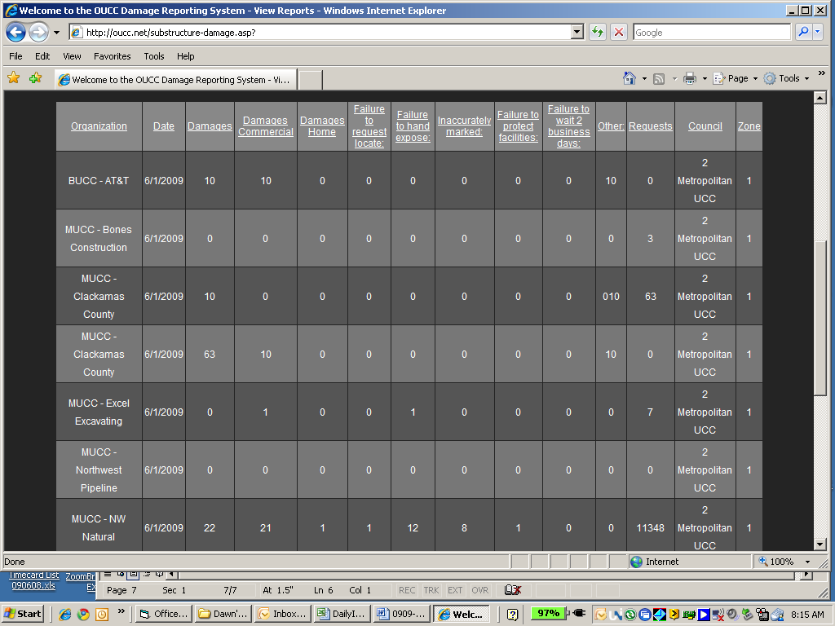
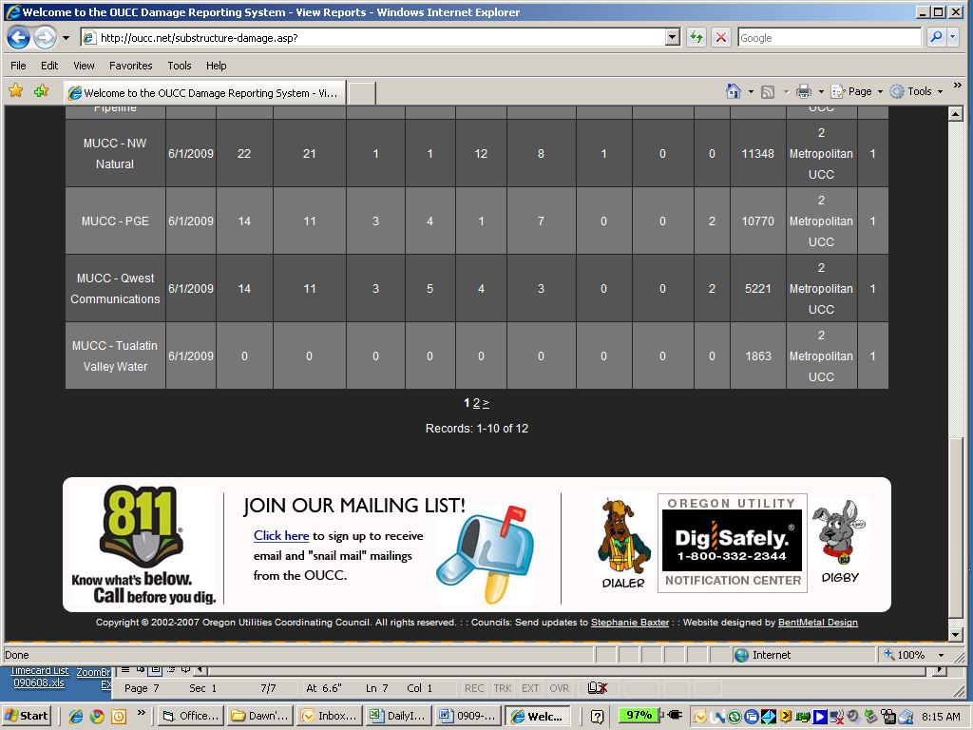
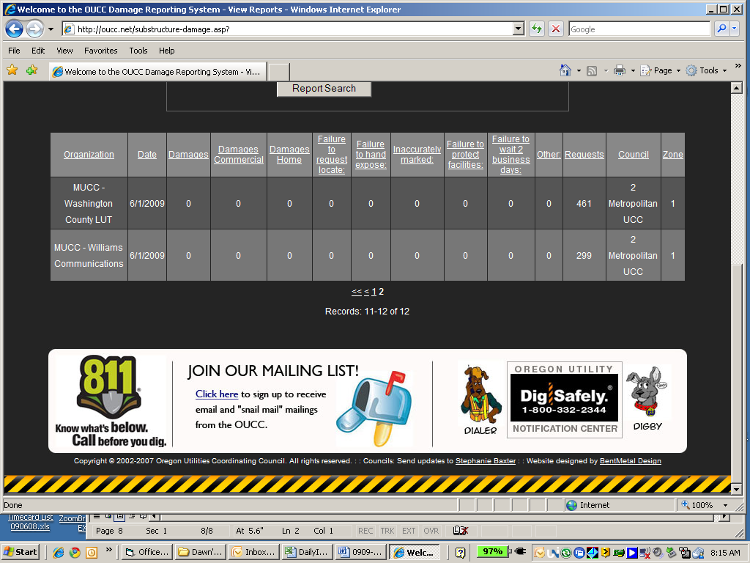

July 2009: TWELVE SUBMITTALS FOR DAMAGES!!!
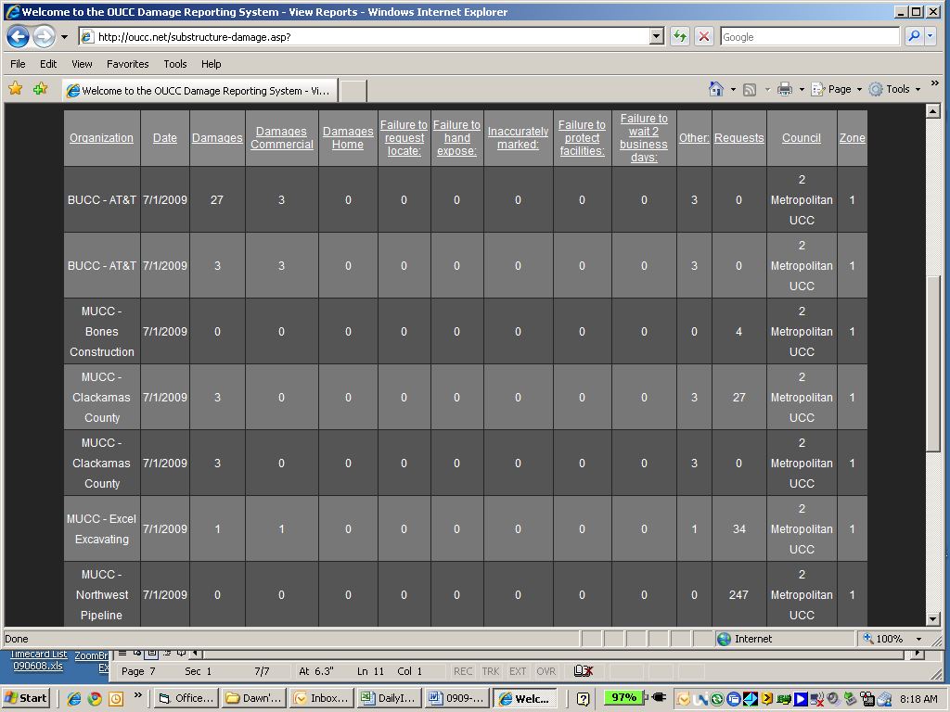

July 2009 continued:
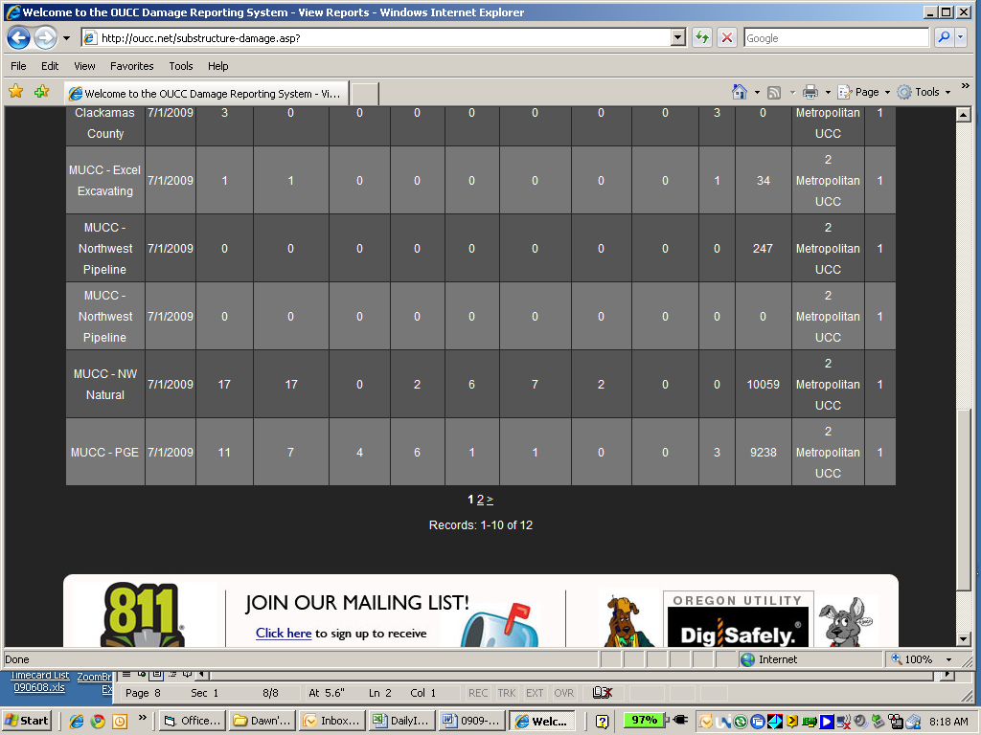
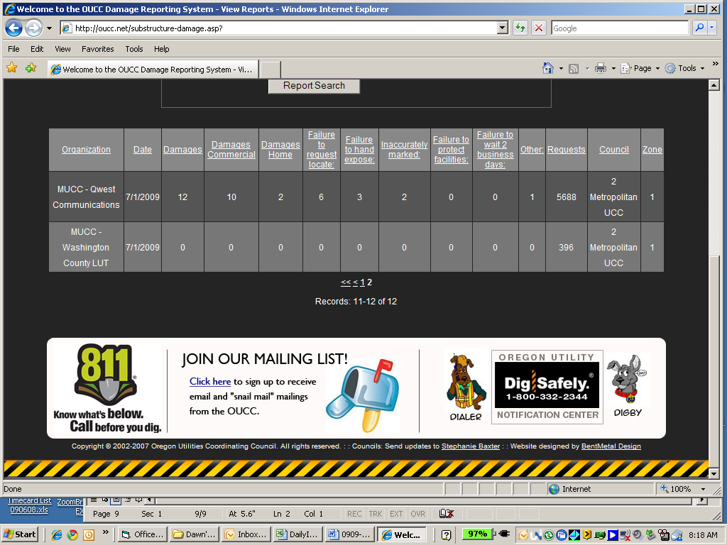

August 2009: SIX SUBMITTALS FOR DAMAGES!!!
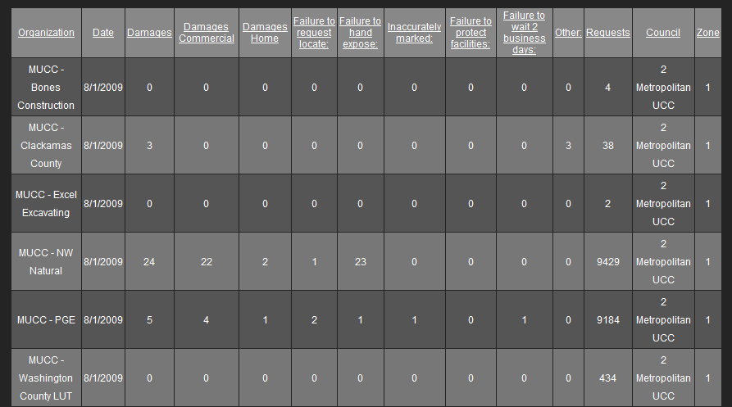

September 2009: THREE SUBMITTALS SO FAR – GET THOSE DAMAGES REPORTED!
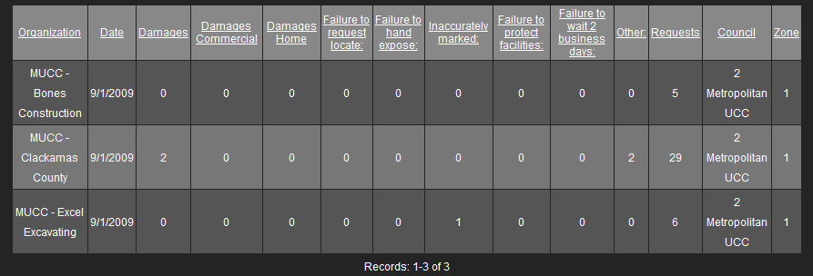

Note: Damages will be updated prior to printing the minutes for the MUCC Meeting on Oct. 28th.

