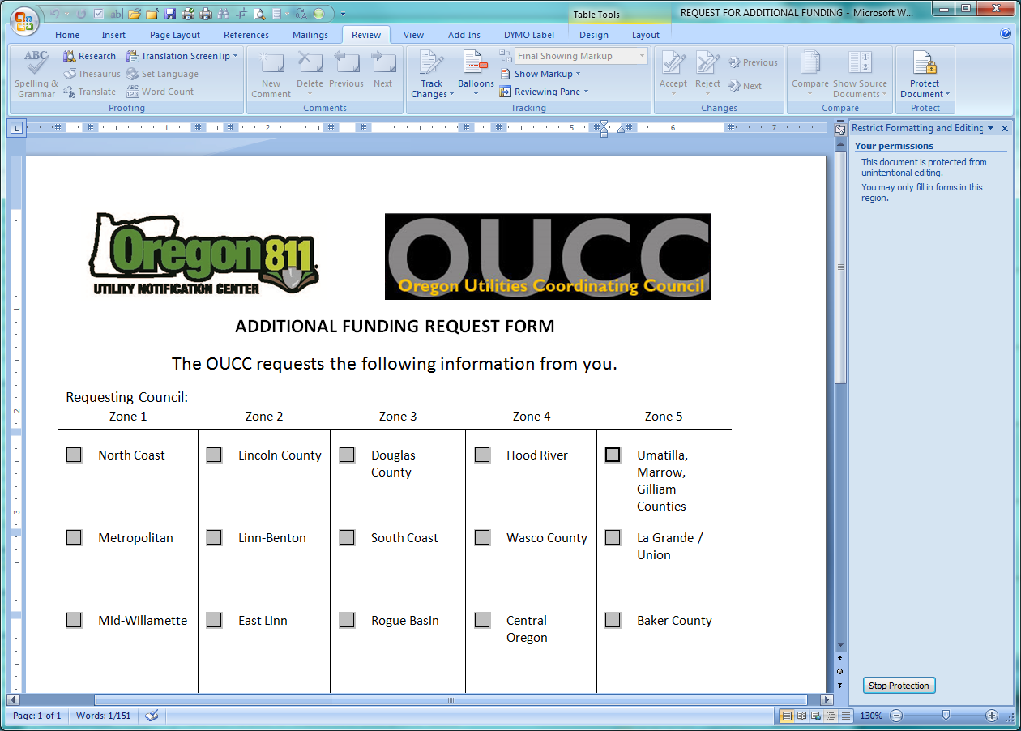

**ADDITIONAL FUNDING REQUEST FORM**

* The purpose of Additional Funding is to help Councils with their P&E Events and training, when there is not enough money in that Council to fund it completely themselves.
* In order to provide accountability of spending to the OUNC, additional information is required. Please fill out this form as completely as you are able to.

The OUCC requests the following information from you.

Requesting Council: **Select your Council**

|  |  |  |  |  |
| --- | --- | --- | --- | --- |
|  |  |  |  |  |

|  |  |
| --- | --- |
| Today’s Date: **Click to enter a date**  Office(s) held:  President Vice President Treasurer  Secretary Damage Chair P&E Chair  Standards Chair  Other **Add Title/Chair held** | Name of Person Requesting Funding:  **Click to add Name**  Mailing Address: **Add Street Address**  City / State / Zip: **Add City, State, Zip** |

__________________________________________________________________________________________________________________________

Event or Purpose for Request (with description): **Click to add Event Name**

Date of Event: **Click to select Event Date** Location of Event: **Click to add Location**

Is there a web link to this event? No Yes - **Click to add Link**

Can it be added to the OUCC Calendar? No Yes

Are you requesting other promotional materials?

No Yes : **Click to add items**

__________________________________________________________________________________________________________________________

Amount of funds in your UCC account prior to this event/training: $

Amount of Request: $       Amount your UCC is contributing: $

Please list any additional events you plan to sponsor through the rest of this year with estimated expenditure:

|  |  |  |
| --- | --- | --- |
| $ | Date: **Add date** | Event: **Click to add Event Name** |
| $ | Date: **Add date** | Event: **Click to add Event Name** |
| $ | Date: **Add date** | Event: **Click to add Event Name** |
| $ | Date: **Add date** | Event: **Click to add Event Name** |

Please submit your request to the Treasurer at [alba.vogland.oucc@gmail.com](mailto:alba.vogland.oucc@gmail.com) for Board review and approval.